The Global Climate Observing System, GCOS
– Programme and System of Systems

This document is synthesizing the objectives of GCOS as a programme and its functionalities as a “System of Systems”.
It has been compiled on request of D/CLW in an effort to analyse all current WMO internal activities with regard “climate”.
(Date: 10 September 2018)

Contents
Brief 3
Objectives of GCOS as a programme 3
GCOS as a System of Systems: 4
GCOS Strategy: Goals, their components and related activities and outputs 5
Strategic Goal 1: Identify user needs. 5
Component to Goal 1: 5
Strategic Goal 2: In order to meet these needs, GCOS aims to ensure that climate observations are enhanced and continued 6
Component to Goal 2: 6
Component to Goal 2 6
Component to Goal 2: 7
Strategic Goal 3: Advocate for free and open access to relevant data. 7
Component to Goal 3: 7
Main Objectives of GCOS Science Panels: 8
Assessing the current state of the global observing system 8
Support and guide the development of the global climate observing system 8
Advocating and promoting the establishment and enhancement of the systems required to provide long-term and consistent data; securing the implementation of designated GCOS networks; 8
Promoting the transfer and accessibility of data to the user community. 8
Promote and advocate the need for good data stewardship including: 8
Identifying measurable key variables 8
Coordinating activities 9
Key Activities of GCOS Science Panels: 9
1: Adequacy 9
Review adequacy and availability of ECV monitoring (G11,12 &13) 9
2: Requirements 9
Routinely maintain, review and revise list of ECV product requirements (G10) 9
3: Progress 10
Monitor progress on implementing actions in Implementation Plan 10
Defining requirements in the future – the process: 10
Open Reviews 10
Work Plan from 2017 to 2022 11

Brief

Co-sponsored program, established 1992 as a consequence of the 2nd World Climate Conference in 1990. Memorandum of Understanding from 1998 is signed from WMO, IOC of UNESCO, UNEP (now Un Environment) and ICSU (now International Science Council). Program was reviewed in 2014 on request of WMO, and review was executed by all four sponsors.
Governance through a steering committee of co-sponsor representatives, who also appointed senior managers as members. Chairman has been appointed in consensus of all sponsors. Director is supporting the Chairman and the Steering Committee, and is raising funds for programme activities.
WMO is supporting (seed money) the D1 and the AA position from Regular Budget (450.000 CHF per annum).
GCOS is a self-financing program, as all activities and secretariat staff is funded through voluntary contributions and extra-budgetary funds (800.000 CHF per annum), which are fundraised by the Director of the programme secretariat.
The programme is centred around science panels and its working groups and task teams, which follow the recommended actions of an implementation plan. The building of the climate system is using the concept of Essential Climate Variables.

Objectives of GCOS as a programme as agreed by its sponsoring organizations during its 2014 review:

GCOS is an active and successful programme serving a broad range of user needs for globally coordinated climate observations. Its goal is to provide comprehensive data and climate information on the total climate system, including a range of physical, chemical and biological properties, along with atmospheric, oceanic, hydrologic, cryospheric and terrestrial processes.

GCOS is working with existing or planned operational and research programmes for acquiring the global climate system data. It enables the identification of data needs to enable the further development of these programmes to ensure continuity and diversification of climate observations. Data needs are organized around the concept of Essential Climate Variables (ECVs).

GCOS delivers the design, plans and architecture for a global climate observing system to support climate research, assessments and services. Its vision is a comprehensive climate observing system supporting climate services and improved understanding of the climate system.

GCOS is the single point for coordination, working through the WMO Integrated Global Observing System (WIGOS), the IOC-led Global Ocean Observing System (GOOS), the Committee on Earth Observation Satellites (CEOS) and the Coordination Group for Meteorological Satellites (CGMS) for implementation; and plays a significant role for the broader observation requirements of the GFCS.

GCOS will ensure data needs are met, as far as possible, by existing operational and scientific observing, data management and information distribution systems, and through further enhancements of these systems, as well as through encouraging new systems to be established. GCOS will be implemented through, inter alia:

(a) WIGOS;

(b) Related atmospheric constituent observing systems managed by the Global Atmosphere Watch (GAW);

(c) Related physical, chemical and biological ocean observations managed by GOOS and its related Framework for Ocean Observing (FOO);

(d) Related land surface ecosystem, hydrosphere, and cryosphere measurements managed by WMO Hydrological Observing System (WHOS), the Global Cryosphere Watch (GCW) related terrestrial frameworks;

(e) The maintenance and enhancement of programmes monitoring other key components of the climate system;

(f) Programmes to monitor the key physical, chemical and biological aspects of the impacts of climate change, including the World Climate Services Programme (WCSP), and the human dimensions of climate change;

- Data communication and other infrastructures necessary to support operational climate forecasting of the WCP, the WMO Information System (WIS) and the Climate Services Information System (CSIS) of the GFCS.

GCOS as programme has to engage in Partnerships:
GCOS is engaged in the development of observing systems that allow the quantification of climate impacts (e.g., health, energy, water and food sectors) and associated information for national economic development. GCOS will strive to strengthen its relations with partners developing new initiatives that address data on interactions between humans and the environment by:

(a) GCOS and partner entities contributing to the Observation and Monitoring pillar of the GFCS devising a joint strategic plan to define the function and responsibilities of GCOS in the GFCS;

(b) GCOS is recognized as an element of the GFCS: GCOS standards, its recommendations for observations, and its strategy for climate observations are in support of the GFCS and, in particular, for the CSIS;

(c) GCOS and GEO developing an effective cooperation with the goal of building a robust and sustained climate observing system;

(d) GCOS and its sponsors communicating with the Global Programme of Research on Climate Change Vulnerability, Impacts and Adaptation (PROVIA) and Future Earth, to clarify the functions and responsibilities of GCOS in their respective activities.

GCOS as a System of Systems:

GCOS should comprise of any data and information on the climate system taken by in situ, airborne or space-based techniques and platforms, while the ownership of the observing systems and networks will remain fully with their operating entities.

The GCOS ECVs comprise all physical, chemical and biological properties needed to describe the climate system. GCOS will:

- Elaborate the ECV concept to specify its key deliverables and outputs, continuing the process of emphasizing fields and products and de-emphasizing individual observing platforms;

- Develop systematic data observation requirements for in situ, airborne and space-based data products for climate.

GCOS Strategy: Goals, their components and related activities and outputs
The strategy of the GCOS programme defined how the climate community should implement, maintain and support the climate observing system through advocating, coordinating and communicating.
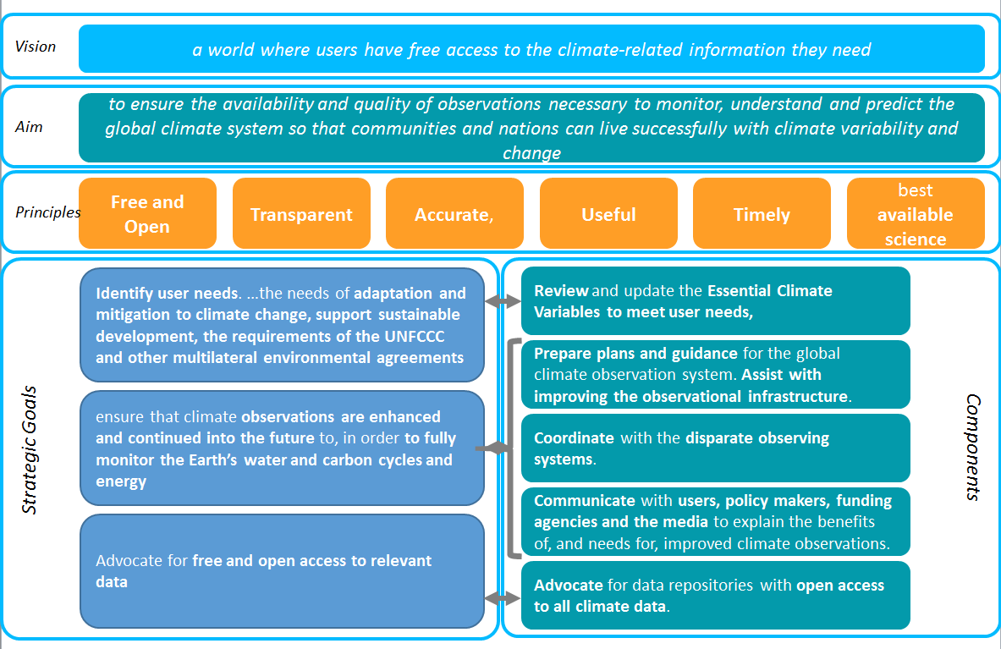

In the future GCOS will have three strategic goals and related components:

Strategic Goal 1: Identify user needs. In particular, identify observations that more fully meet the needs of adaptation and mitigation to climate change, support sustainable development, the requirements of the UNFCCC and other multilateral environmental agreements (MEA).

Component to Goal 1: Review and where needed update the definitions of Essential Climate Variables considering the expanded observational needs for adaptation and mitigation to climate change. Monitoring the performance of the observational systems against these needs.

Activities (not complete):
- GCOS science panels driving the ECV review and monitor the implementation of actions
  - Output: ECV Fact sheets informing on state-of-the-art; dedicated ECV Stewards
- TOPC Task Team on Adaptation
  - Output: Advice on observation requirements for adaptation measures
- Steering Committee Task Team on UNFCCC Paris Agreement
  - Output: Advice on how observations can support the Paris Agreement and its Global Stocktake

Strategic Goal 2: In order to meet these needs, GCOS aims to ensure that climate observations are enhanced and continued into the future to provide the empirical evidence needed to understand and predict the evolution of the climate, to guide mitigation and adaptation measures, to assess risks and enable attribution of climatic events to underlying causes, and to underpin climate services. GCOS will need to support integrated observations of the physical, chemical and biological properties and processes across the atmospheric, oceanic and terrestrial domains, in order to fully monitor the Earth’s water and carbon cycles and energy.

Component to Goal 2: Prepare plans and guidance for the maintenance and improvement of the global climate observation system.
Assist with improving the observational infrastructure in countries with limited resources (the GCOS Cooperation Mechanism, GCM).
Assist the integration of national and regional networks into the global observing systems.

Activities (not complete):
- GCOS review and assessment cycle which produces as output every 5-6 years a status report and an implementation plan.
- Regional Workshops:
  - First Regional workshop held in Fiji for Pacific Island States, in fall 2017.
  - Ouput: Regional plan how to improve the networks
  - Second Regional Workshop planned in Uganda, Entebbe, in fall 2018
  - Ouput: Regional plan how to improve the networks
- GCOS Cooperation Mechanism:
  - GUAN stations in need of performance improvement

Output: Improved reporting

- Monitoring Network Perfomance:
    - CBS Lead Centers for GCOS: Monitor of all WMO regions the performance of upper-air and surface stations
    - Monitoring Centres for GCOS Surface network at DWD and JMA
    - Monitoring Centre for GCOS Upper-Air network at ECMWF
    - World Radiation Monitoring Centre for BSRN, at AWI, Bremerhaven

Output: Monitoring statistics reports

Component to Goal 2: Coordinate with the disparate observing systems.
Encourage the adoption of GCOS ECV in their plans and ensure the definition and requirements of ECV do not lead to unnecessary duplication.

Activities (not complete):
- Coordinated space-based climate observations through CEOS-CGMS
  - Output: ECV inventory; Projects on monitoring ECVs from space worth 100 Mio Euros
- Task teams in Lightning & Radar, both started work in 2017
  - Output: Advice on how to use lightning and radar data for climate monitoring
- Working group on GCOS Reference Surface Network meets for first time in 2017
  - Output: position paper “Towards a global land surface climate fiducial reference measurements network”, published in the International Journal of Climatology in 2018 (DOI: 10.1002/joc.5458)
- Working group on GRUAN: implementation and coordination of the GCOS Reference Upper-Air network through several task teams and a lead centre
  - Output: certified GRUAN stations and data; scientific publications
- Task team on Global Upper-Air Network GUAN
  - Output: network maintenance based on decisions based on performance reports
  - Coordinate with IOC-led Global Ocean Observing System GOOS and joint WMO-IOC JCOMM OCG through the OOPC:
    - Task Team of Air Sea Fluxes to oversee the development of a strategy for observations:
    - Output: Community Whitepaper in OceanObs’19

Component to Goal 2: Communicate with users, policy makers, funding agencies and the media to explain the benefits of, and needs for, improved climate observations. Promote examples of the strong impact that GCOS can make in developing countries with direct societal impacts

Activities (not complete):
- Development of a set of indicators as communication tool
- Promote the ECV Inventory, as part of the Architecture for Climate Monitoring from Space
- Improving the web page

Strategic Goal 3: Advocate for free and open access to relevant data.

Component to Goal 3: Advocate for, and facilitate, the establishment and maintenance of data repositories with open access to all climate data. The aims and objectives of GCOS will only be met if the data is accessible by users

Activities (not complete):
  - Promote the ECV Inventory
  - Advice and promote projects which have committed that their ourput is free and open accesible, for example the ESA Climate Change Initiative.

Main Objectives of GCOS Science Panels:

Assessing the current state of the global observing system for climate, and identifying its gaps and inadequacies and designs to ensure long-term monitoring;

Support and guide the development of the global climate observing system
- Provide climate monitoring principles and guidelines that, when followed, will ensure observations are of a sufficient quality for use for climate purposes;
- Promote the idea of reference networks: networks that make observations to the highest practical quality, are traceable to standards and can be used to improve the wider networks;
- Ensure the observing system meets the required climate data quality;
- Identify possible improvements in the global climate system and advocate for their implementation
- Support local and regional monitoring to support adaptation;
- Support capacity building, especially practical technical support, and find donors to support this;
- Review the adequacy of the ECV observational systems, identify gaps and issues. Prepare and promote plans to address these issues.

Advocating and promoting the establishment and enhancement of the systems required to provide long-term and consistent data; securing the implementation of designated GCOS networks;
- Advocate for how the climate community should implement, maintain and support the climate observing system.
- Explain the need for observations, the role of GCOS and information related to ECV observations,
- Increase the visibility of the programme, its achievements and ambitions using available and modern media tools;
- Develop a communication strategy that will provide additional clarity about the purpose of GCOS.

Promoting the transfer and accessibility of data to the user community.

Promote and advocate the need for good data stewardship including:
- Easy data access and discoverability
- Free and open data policies
- Comprehensive metadata
- Support to national, regional and global data centres
- Ensuring the long-term (indefinite) accessibility of data
- Use of digital object identifiers for data records
- Data to be correctly cited and credited
- Climate data management procedures and standards

Identifying measurable key variables that control the physical, biological and chemical processes affecting climate, and are indicators of climate change;
- Parameters that need to be observed in order to monitor the state and changes of the global climate system; to support planning for adaptation to, and mitigation of, climate change; and to communicate the state of the climate system and its changes.
- Consider observational needs of users planning adaptation to, and mitigation of, climate change, at global, regional and national levels.
- For each ECV specify the products required and their requirements, at global and, if needed, regional and local scales (e.g. resolution, accuracy and stability)

Coordinating activities with other global observing systems, panels and task groups to ensure the consistency of requirements with overall programmes.
- with other observing systems, such as WIGOS, GAW, GCW, WHYCOS, GOOS etc.. Explore synergies with observing needs for non-climate environmental issues.
- Coordinate with relevant stakeholders such as UNFCCC, WMO, IOC of UNESCO, ICSU, UNEP, Other MEAs, IPCC and GEO

Key Activities of GCOS Science Panels:

1: Adequacy

Review adequacy and availability of ECV monitoring (G11,12 &13)
- Use existing systems where they are available
- Need an annual process
- Need to involve other actors
- CEOS/CGMS WGClimate is doing this for satellite data records
  - ECV Inventory
- May need to consider capacity development needs

2: Requirements

Routinely maintain, review and revise list of ECV product requirements (G10)
- 3-year process (to be ready for update of Implementation Plan)
- Extensive public consultation and review
- Links to adaptation and mitigation needs and regional activities

Routinely maintain, review and revise list of ECV product requirements (G10)
- GCOS Implementation Plan 2016 presented ECV product requirements
  - Covering all ECV products, not just satellite-based products
  - These were revised by panels
  - Only review was part of the review of the Implementation Plan
  - Has been criticism alleging lack of openness & transparency
  - GCOS needs a formal process for the update in 5-years time
- Aims
  - Make the process of preparing revised requirements open and transparent
  - Allow the whole community to feel involved in refining the requirements
  - Better understand how the requirements match user needs
  - Link to the targets for understanding climate cycles
  - Increase understanding of GCOS and its aims
  - To provide a plan for the next 5 years

3: Progress

Monitor progress on implementing actions in Implementation Plan
- An annual process for the panel
- Need to allocate responsibilities for each ECV

Defining requirements in the future – the process:
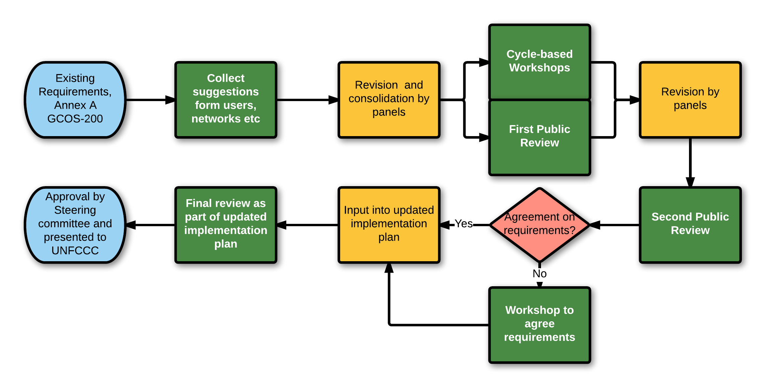

Open Reviews
- Involve the widest possible range of contributors
- be open and transparent
- be seen to be listening to the community: not dictating to it
- This is an opportunity to explain GCOS’s role and significance

Open to all:
- Modelling groups
- Lead authors of relevant IPCC chapters
- CEOS/CGMS
- Climate Services
- GFCS
- Copernicus
- NHMS
- Observing Systems – GOOS, GWOS …

Output:
Considerations of
- How well do existing requirements match with the targets for cycles?
  - What changes are needed to the requirements to meet these targets
  - Are any additional parameters needed to close the cycles?
    - Can they be proposed as ECVs?
  - Are the targets for the cycles reasonable and practical?
- Climate cycles cross domains: atmosphere-oceans-terrestrial
  - Science panels will need to collaborate on each cycle
- Should GCOS hold workshops on each climate cycle?
- How should GCOS make this process authoritative?

Work Plan from 2017 to 2022

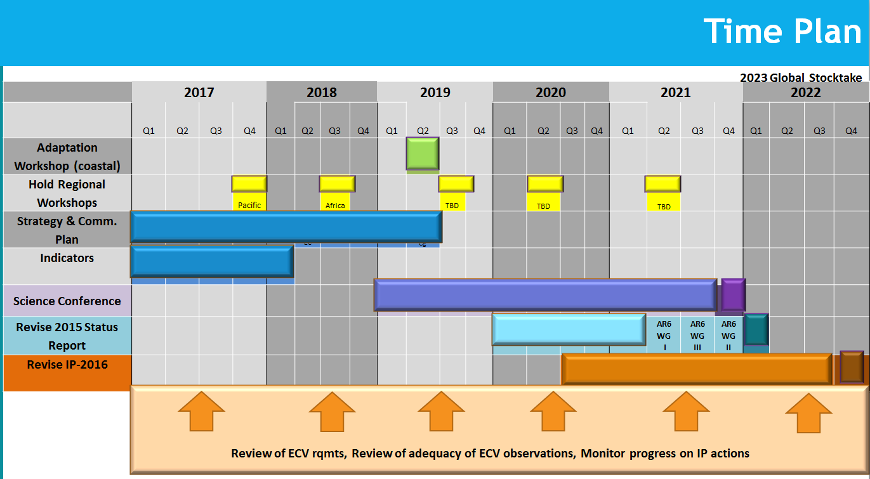

References:
- Memorandum of Understanding (1998),
- Draft MoU from July 2017, incorporating the recommendations of the program review 2014
- GCOS Implementation Plan from 2016
- GCOS Strategy, draft from 2018

