A discussion document on the size, composition, and terms of service for the Working Group on GRUAN

22 December 2017

Introduction
The purpose of this document is to describe a proposed revised structure for the GRUAN Working Group (WG). The current Terms of Reference for the WG are included in Appendix A.

Current Structure
At present, the WG comprises 2 co-chairs, 11 standard WG members, 10 task team co-chairs, and ex-officio positions. This is 35 WG members, which may have the appearance of being too large.

Proposed Revised Structure
The proposed structure is built on the idea that every position has a purpose – there would be no ‘general’ WG members. People would hold WG positions to fulfil specific needs of the WG. Most of these positions connect the WG to allied organisations and/or communities with vested interests in GRUAN’s activities. This includes connections to the GRUAN Task Teams.
- The Working Group would be formally defined as all positions marked in orange in Figure 1. This includes:
  - The two GRUAN co-chairs
  - Two Science Coordinators
  - Head of the Lead Centre
  - The two co-chairs from each of the five Task Teams:
    - Radiosonde
    - Sites
    - Ancillary
    - Scheduling
    - GNSS-PW
  - A person identified as the liaison for each of the following stakeholder communities:
    - Statistics
    - Satellite
    - WIGOS metadata
    - Metrology
    - SHADOZ & NDACC
    - ARM
    - GAW
Note that these seven positions differ somewhat from the six discipline-specific positions defined in the current terms of reference. This would bring the formal size of the WG to 21 members.
- These proposed roles within the WG are position specific, rather than person specific. For example, if the current Statistics liaison were to leave the WG, a replacement for that specific role would need to be found.
- The people in the positions that connect GRUAN, and in particular the WG, to external communities would be responsible for liaising and/or working with the external communities indicated with outgoing arrows in Figure 1.
- Ex-officio members (shown in pink in Figure 1), while not formally part of the WG, would be welcome to attend every WG call and every ICM, and shall be invited to every WG call and every ICM. They are included by virtue of the organisations that they represent (as indicated by the incoming arrows in Figure 1), and, for all intents and purposes, they would act as members of the WG. They may nominate proxies for any WG calls and/or ICMs they are not able to attend in person. There are currently 9 people identified in these positions.
- Co-chair positions are for one 4-year period. Additional terms require a 2/3 majority support of both AOPC and the formal WG members. Replacements should be staggered by 2 years so that both co-chairs do not change at the same time. Co-chairs may continue to be involved in the WG by taking up some other position within the WG. Six months before a co-chair position becomes vacant, the WG shall propose nominees to fill the vacant position to the AOPC co-chairs. The AOPC co-chairs shall then appoint, from that pool of nominees, and in consultation with the remaining co-chair, a replacement for the out-going co-chair.
- Task team co-chair positions are for one 4-year period. Additional terms require the support of the WG co-chairs and at least 2/3 of task team members. Replacements should be staggered by 2 years so that both co-chairs do not change at the same time. Six months before a Task Team co-chair position becomes vacant, the WG co-chairs will call for expressions of interest for these positions to be filled and, together with the remaining co-chair, will identify a replacement.
- Science Coordinator positions are for one 4-year period. Additional terms require the support of the WG co-chairs and 2/3 of WG members. Replacements should be staggered by 2 years so that both Science Coordinators do not change at the same time. Six months before such a science coordinator position becomes vacant, the WG co-chairs will call for expressions of interest for the position to be filled and, together with the remaining science coordinator, will identify a replacement.
- The seven remaining WG positions, that link the WG to key external communities, are for one 4-year period with possible extensions to additional 4-year periods at the discretion of AOPC and WG co-chairs. Six months before such positions become vacant, the WG co-chairs will call for expressions of interest for these positions to be filled and, together with the incumbent, will identify replacements.
- The timing of periods for all positions detailed above would start on the date of acceptance of these revised terms of reference.
- In seeking to fill vacant positions, every effort shall be made to ensure regional, gender and age balance, as well as capitalizing on opportunities for succession planning, in the composition of the WG.

Co-chairs | Science coordinators
Greg Bodeker | Tom Gardiner
Peter Thorne | Richard Querel
Radiosonde TT chairs  GRUAN radiosonde programmes | Sites TT chairs  GRUAN site representatives
Masatomo Fujiawara | Dale Hurst
Christoph von Rohden  GRUAN ancillary measurement programmes | Belay Demoz
Ancillary TT chairs | Scheduling TT chairs  WIGOS metadata task team
Thierry Leblanc | Tom Gardiner
Tony Reale | Fabio Madonna
Head of Lead Centre  GRUAN Lead Centre | WIGOS metadata liaison
Ruud Dirksen | Arnoud Apituley  MeteoMet, EURAMET and BIPM
GNSS-PW TT chairs  GRUAN GNSS-PW programmes | Metrology liaison
Kalev Rannat | Andrea Merlone
June Wang | SHADOZ & NDACC liaison  SHADOZ and NDACC
Statistics liaison  Statistics community | Anne Thompson  ARM
Alessandro Fasso | ARM liaison
Satellite liaison  Satellites community | Nicki Hickmon
Stephan Bojinksi | GAW liaison
 | Geir Braathen
GCOS Secretariat rep.  GCOS Secretariat | NOAA/ARL rep.  NOAA/NCEI
WIGOS rep.  WIGOS | WMO/OBS rep.  WMO/OBS
GSICS rep.  GSICS | CIMO rep.  CIMO
CAS/ rep.  CAS | CCL rep.  CCL
CBS rep.
CBS
GAW
Figure 1: A graphical representation of the composition of the WG group under the proposed revised structure.

Responsibilities of the WG co-chairs shall be to:

- Coordinate tasks with other co-chair
- Together with the GCOS Secretariat, the Lead Centre and local hosts, plan annual Implementation and Coordination Meetings (ICMs)
- Together with the Working Group and Task Teams oversee the development and revision of GRUAN Implementation Plans
- Coordinate GRUAN representation at annual meetings of the Atmospheric Observation Panel for Climate (AOPC).
- Enhance communication between GRUAN and its various end-user communities.
- Liaise with GRUAN task teams to progress the development required to bring new GRUAN data products online.
- Oversee the preparation of relevant documentation, including technical documents, reports and international peer reviewed literature.
- Oversee the certification process of GRUAN sites
- Oversee succession planning for Working Group members and Task Team co-chairs.
- Oversee the auditing for compliance of GRUAN sites with GRUAN operating protocols
- Promote GRUAN at the national and international level in order to encourage the support of GRUAN (role as “GRUAN ambassador”)

Appendix A

Terms of Reference for AOPC Working Group on GRUAN

Terms of Reference (July 2014)

Background
The GCOS/WCRP Atmospheric Observation Panel for Climate (AOPC) Working Group on GRUAN (WG-GRUAN) was established in 2006 in recognition of the importance of initiating reference-quality observations of vertical profiles of essential climate variables from the surface into the stratosphere to enhance monitoring and understanding of climate variability and change.

The 2004 GCOS Implementation Plan identified the establishment of a reference-quality network as “a very high priority”. The 2010 Update of the GCOS Implementation Plan (GCOS-138) reiterated the call for the establishment of the GCOS Reference Upper-Air Network (GRUAN) for reference upper-air measurements and a complementary system for reference measurements from satellites, and support of reanalysis and reprocessing activities as a key need. Since 2008, the German Meteorological Service, Deutscher Wetterdienst (DWD), have been hosting the GRUAN Lead Centre, consisting of scientific and secretarial support at their Lindenberg Observatory to oversee day-to-day operations of the network. Involvement of WMO in GRUAN operations occurs through representatives from relevant WMO Technical Commissions as ex-officio members on the WG-GRUAN. The initial GRUAN Implementation Plan (GCOS-134), published in 2009, is superseded by the new GRUAN Implementation Plan, covering the period 2013-2017, published in January 2013 (GCOS-165).

It is the Working Group’s responsibility to facilitate this implementation, liaising with other groups and national and international bodies to ensure that an eventual GRUAN is fit for purpose, robust and has the required long-term commitment and management structures. The WG-GRUAN also provides guidance to the GRUAN Lead Centre. The WG-GRUAN membership consists of a broad range of scientific and technical experts who contribute expert oversight and support to GRUAN development and operations.

The AOPC, supported by the GCOS Secretariat, and guided by the GCOS Steering Committee, provides direction and oversight of GRUAN. The WG-GRUAN provides direct guidance on the operation of GRUAN and is supported by specific GRUAN Task Teams. A GRUAN Scientific Coordinator guides the initiation and undertaking of specific research projects in support of GRUAN operations. The day-to-day management and coordination of the network, including training and ensuring the archival and dissemination of GRUAN data, is the responsibility of the GRUAN Lead Centre. An organizational structure for GRUAN as a whole is given in Figure 1.
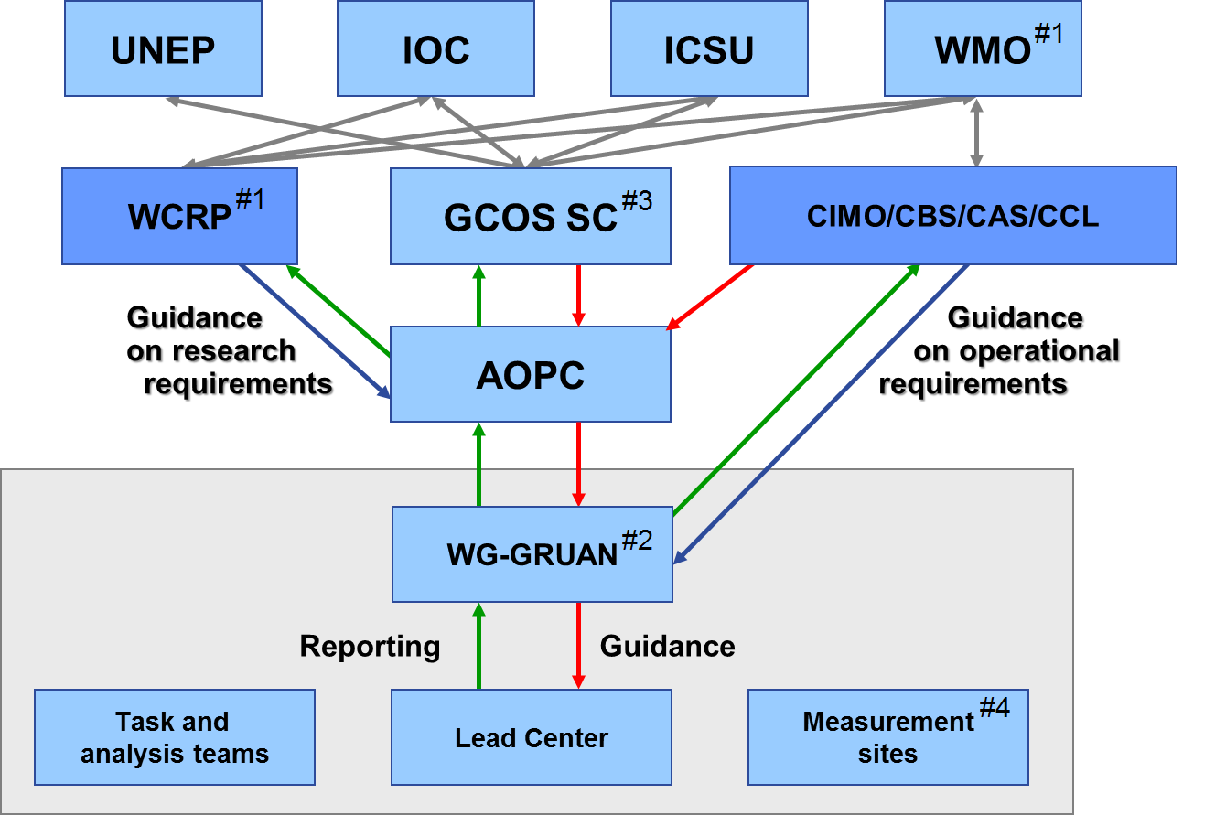

Working group roles and responsibilities
The WG-GRUAN has a range of roles and responsibilities that have been arranged under broad categories that reflect the core facets of its work.

Purpose
- To provide scientific, technical and management oversight of the operations of the GRUAN Lead Centre, which will manage the overall work and evolution of the network, and which shall formally report to the WG-GRUAN at least twice a year;
- To define roles and responsibilities of the GRUAN Lead Centre and, as deemed appropriate, other centres, for data management, quality monitoring, analysis and capacity development purposes;
- To initiate, approve, manage and dissolve, as appropriate, task teams established to undertake specific activities in support of GRUAN;
- To encourage and support the research activities of GRUAN and appoint the GRUAN Scientific Coordinator;
- To ensure that GRUAN operations are well aligned with the goals and directions of GCOS through liaison with the AOPC;
- To ensure that GRUAN operations are well aligned with WMO goals and directions through the representatives of WMO Technical Commissions;

Membership
- The Chair or Co-chairs are appointed by the AOPC.
- Working Group members are approved by the AOPC.
  - Co-chairs from each Task Team are expected to be WG-GRUAN members.
  - At least one member shall represent each of the four WMO Technical Commissions associated with GRUAN (Figure 1).
  - At least one expert in the following fields shall be a member of the WG-GRUAN to ensure a wide range of views:
    - Climate science
    - In-situ atmospheric observations
    - Satellite observations
    - Numerical Weather Prediction / Reanalyses
    - Statistics
    - Metrology
- The Working Group appoints a GRUAN Scientific Coordinator who will also be a member of the Working Group.
- Members will be expected to serve for at least two years or until their membership is reviewed.

Site selection, assessment, and certification
- To define essential and desirable requirements of GRUAN sites in terms of operational principles, the collection of metadata, assessment of measurement uncertainties, data management, variables addressed, and instrumentation. Develop these requirements in consultation with other relevant observing programmes, make them publically available, and periodically reassess their validity;
- To certify sites based on (i) information submitted by the site, (ii) an assessment made by the Lead Centre, and (iii) potentially on-site assessment by WG and/or Lead Centre members, against the set of requirements. Periodically reassess/audit sites against these requirements;
- To decide on the composition of GRUAN, including the selection of sites. This should be done in consultation with AOPC and other advisory bodies as appropriate;

Coordination
- Together with relevant stakeholders, to plan and realize annual Implementation and Coordination Meetings (ICMs) to be hosted at, or associated with, a GRUAN site and to include a site visit;
- To report at least annually to AOPC on its activities, including the progress towards a reference network, the performance of the network once established, the uses and value of the data collected, and the implications for the global observing system;
- To ensure that the GRUAN Implementation Plan and individual work plans from ICMs are carried out, including but not limited to undertaking those activities mandated to the WG-GRUAN;
- To evaluate 6-monthly progress reports from the Lead Centre and GRUAN Task Teams and provide feedback in a timely manner;

Advocacy and outreach
- To work with relevant agencies and programmes to define and promote GRUAN for long-term upper-air reference observations of a range of specific variables, and to make optimal use of existing and planned infrastructure within the WMO Global Observing System. This includes inter-alia, working with the WIGOS Project Office as a WIGOS pilot project; the WMO Space Programme, CBS and CIMO on satellite and radiosonde calibration and validation issues, including reference instrumentation and metadata;
- To provide for appropriate communication and outreach activities (through activities such as conferences, making connections with other programmes, organizing special conference sessions on GRUAN etc.).
- To work with strategic partner organizations and projects as specified from time to time inter-alia by AOPC, in annual Implementation and Coordination Meetings or in the GRUAN Implementation Plan.
- WG-GRUAN members should actively work to attract funding in support of WG activities.
Mode of operation
The WG-GRUAN co-chairs convene regular calls with the Lead Centre staff to discuss progress and topics related to the ongoing functioning of GRUAN.
- The WG-GRUAN will generally correspond by e-mail and teleconferences (to be undertaken every other month), and take advantage of relevant workshops and conferences to hold meetings (in addition to meeting at the time of ICMs). Additional meetings will be convened by the Chair(s) upon demand, in consultation with the GCOS Secretariat and GRUAN partner institutions.

These Terms of Reference will be subject to periodic review by AOPC in liaison with the Co-chairs of the Working Group and the Lead Centre.

Glossary

AOPC = Atmospheric Observation Panel for Climate
CAS = Commission for Atmospheric Sciences
CBS = WMO Commission for Basic Systems
CCL = Commission for Climatology
CIMO = WMO Commission for Instruments and Methods of Observation
GCOS = Global Climate Observing System
GRUAN = GCOS Reference Upper Air Network
ICM = Implementation - Coordination Meeting
ICSU = International Council for Science
IOC = Intergovernmental Oceanographic Commission
NWP = Numerical Weather Prediction
UNEP = United Nations Environment Programme
WCRP = World Climate Research Programme
WIGOS = WMO Integrated Global Observing System
WMO = World Meteorological Organisation

All acronyms are defined in a glossary at the end of the document.

