Advancing Sustained Observations: the Evolving relationship between GCOS and GOOS.
For discussion at the 26th Session of the GCOS Steering Committee, 23-26th October 2018, Helsinki, Finland.
- Introduction.
This paper outlines the evolving relationship between GCOS and GOOS and their complementary and consistent strategies. It shows how each programme contributes to each other’s strategic objectives, and makes recommendations on future joint activities and priorities. The paper will also discuss the co-parenting of the joint panel OOPC, given its complex role in delivering to two programmes.
The GCOS and GOOS programmes have common goals in ensuring the development of global sustained observations. Hence there are many areas in which GCOS and GOOS could work together; particularly in aspects related to communications and engagement, and ensuring the delivery of data, products and information to meet the needs of science and society. Furthermore, context for sustained observing (including drivers and capabilities) are shifting, and given GCOS and GOOS’s overlapping interests and common challenges, it is timely for the programmes to consider how they will work together into the future.
GCOS is increasingly focusing on integration across the domains with the aim of tracking the major climate cycles and ensuring a consistent approach to their observation within the climate system. The programme is also working towards developing adaptation and mitigation requirements, which will imply stronger requirements local measurements, including coastal ocean observations of particular relevance to GOOS.
GOOS is becoming increasingly multidisciplinary due to efforts to develop integrated requirements and observing system design in support of climate, operational services and ocean health.
In this shifting environment, both GCOS and GOOS have developed forward programmatic strategies. This paper addresses synergies and differences in priorities, and the coordination and support of activities at the interface.
This document is organised as follows, 2. Introducing the GCOS and GOOS Strategies, and how the programmes contribute to each other’s strategies, 3. How GCOS and GOOS can work together on common goals (partnerships with common sponsors, space agencies and with organisations for delivery; setting and reviewing requirements) and 4. Co-parenting OOPC; some proposed actions are identified throughout the document.

2. GCOS and GOOS Forward Strategies
The Strategies for both GCOS and GOOS are under development and outline a set of strategic goals or objectives. The strategies are in part reflective of the status and maturity of the programme components.
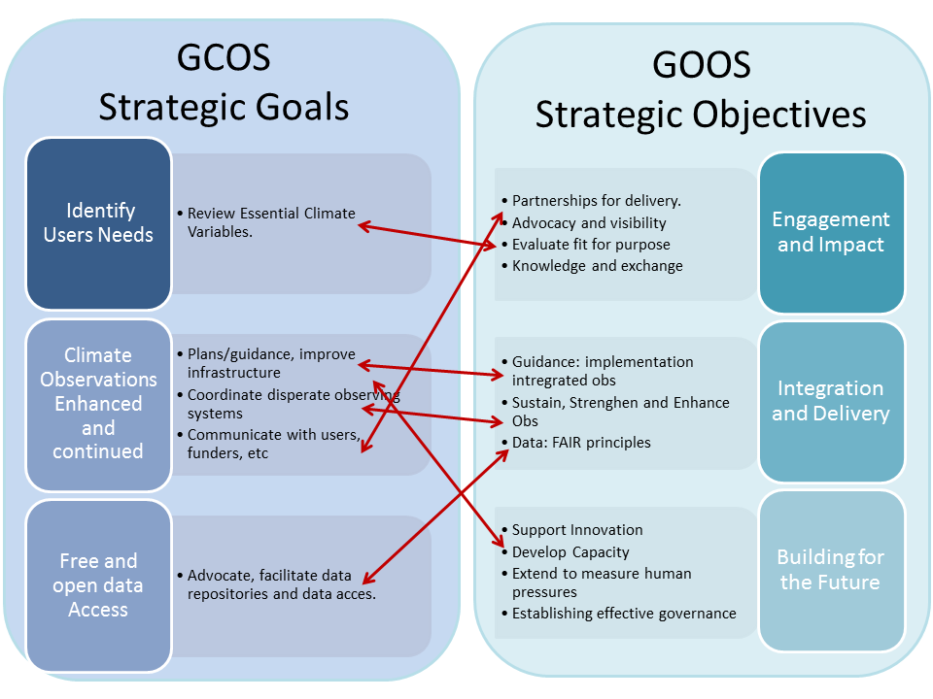
Figure 1. Comparing the GCOS and GOOS strategic goals.
The GCOS Plan strategic goals identify a set of foundation tasks/processes of the programme around assessing requirements for and implementation of Essential Climate Variables (ECVs).
The GOOS Strategic Plan is forward looking in developing partnerships and pathways to impact for the programme, and for the ocean observing system as a whole.

2.1. How GOOS helps to deliver the GCOS Strategy

While OOPC is a joint panel of GCOS and GOOS, GCOS needs to draw from further components of GOOS (through engagement with OOPC) in order to deliver the overall GCOS strategy.
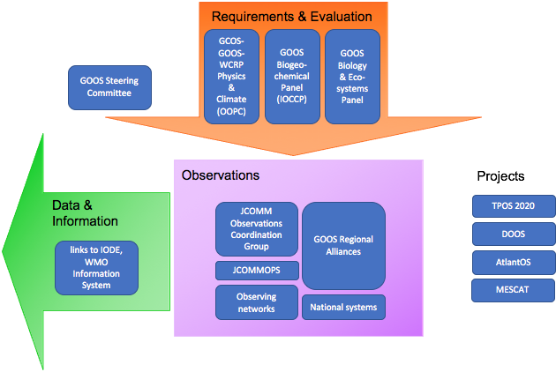

Figure 2. The Components of GOOS.

GOOS is organized under a Steering Committee, which sets strategy, implementation plans, manages partnerships, and reports to sponsors. It follows the Framework for Ocean Observing, which in turn was inspired by GCOS best practices. Three GOOS panels set requirements based on end user needs and lead evaluation of the observing system: the Ocean Observations Physics and Climate Panel (OOPC, joint with GCOS and WCRP), the Biogeochemistry Panel (based on the International Ocean Carbon Coordination Project), and the Biology and Ecosystems Panel. Coordination of implementation of global networks is done through the JCOMM Observations Coordination Group, which oversees a technical coordination unit (JCOMM Observing Programme Support Centre), and through thirteen GOOS Regional Alliances. GOOS Projects work to improve the readiness and capability of the observing system, with a focus on leaving a legacy for the observing system.

OOPC is the entry point for GCOS into GOOS, and draws on these many GOOS structures to deliver on GCOS’s Strategic Goals. This is a key feature of the relationship between GCOS and GOOS, and their communication.

Strategic Goals | Components | OOPC Role | Contributing GOOS activities
Identify User Needs | Review Essential Climate Variables | Setting, reviewing requirements for ECVs, EOVs (drawing on EOV Specifications) | GOOS Biogeochemistry (BGC) Panel, Biology and Ecosystems (BioEco) Panel
Climate Observations enhanced and continued | Plans/guidance, improve infrastructure  Coordinate with disparate observing systems  Communicate with users, funders, policy, media. | Observing System Reviews  Overseeing Observing System implementation and performance  Brokering multiplatform observing system design, targets.  Reviews and development projects, talks, engagement with programme managers. | Working with other GOOS BGC Bio panels, JCOMM OCG  GOOS Projects  Network based coordination and tracking through JCOMM OCG JCOMMOPS  JCOMM OCG  GOOS Regional Alliances  Other GOOS Panels.  GOOS SC  GOOS Secretariat
Free and Open Data Access | Advocate, facilitate data repositories and data access. | Advocating the benefits of global observations; FAIR Principles  (Findable, Accessible, Interoperable, Reusable). | JCOMM OCG, JCOMMOPS  Other GOOS Panels  (Additional partners such as IODE OceanPredict WIS etc.)
Table 1. How GOOS helps to deliver the GCOS Strategy.

Identifying User Needs: Setting and reviewing requirements for ocean Essential Climate Variables is a core role of OOPC. Given the demand for increasingly multidisciplinary requirements for climate observations (move towards earth system approaches, demand for understanding impacts, adaptation), and advances in observing capability, OOPC needs to increasingly work with the other two panels of GOOS for Biogeochemistry and Biology to articulate climate specific requirements for ocean observations and to ensure that the totality of climate requirements for observations can be clearly articulated.

Ensure Climate Observations are Enhanced and Continued: This is ensured through OOPC’s strong relationship with the JCOMM Observations Coordination Group, and the GOOS regional alliances (in addition to the GOOS Biogeochemistry and Biology Panels of GOOS) for tracking implementation of in situ observing networks. Engagement with Satellite programmes is discussed in more detail in section 3.1.4.

A Core focus of OOPC is also on observing system reviews and development projects which aim to;
- Advance observing system design and innovation.
- Strengthen integration,
- Broaden participation (nations, agencies, experts)
- Strengthen delivery.

Communication with users, funders, policy makers and the media is carried out at the working level through Reviews and development projects, talks, engagement with programme managers and contributions to the GCOS assessment and review process. At the higher level communications are largely driven through the GOOS Steering Committee and the Secretariat.

Free and open data access is advocated through the GOOS panels in order to deliver global datasets and applications. Regional projects also have a strong focus on data delivery as do the GOOS Regional Alliances. JCOMM OCG coordinates standards and best practices across in situ observing networks, part of which is related to data delivery standards. JCOMMOPS tracks data delivery in real-time and delayed mode.

2.2. How GCOS helps to deliver the GOOS Strategy

In contrast to the contributions of GOOS to GCOS, the contributions of GCOS to the GOOS strategy are largely focused at the high level partnerships and advocacy level. This fits with the idea that GCOS is a ‘system of systems’ and the GOOS (through OOPC), provides the ocean component to this. GOOS relies on GCOS to facilitate the partnerships required for delivery of the Climate theme of GOOS.

Engagement and Impact, GCOS largely contributes to GOOS through facilitating the partnerships required with WCRP, IPCC, and UNFCCC in order to deliver on the climate theme.

Integration and delivery, GCOS largely contributes to the goal for Findable, Accessible, Interoperable Reusable (FAIR) data, focusing on free and open data access, and adherence to the Climate Monitoring Principles.

Building for the Future, GCOS has the potential to contribute through several aspects; for Capacity Building and broadening participation, there is the potential to leverage the GCOS Cooperation Mechanisms for some observations, particularly in the coastal zone such as Tide Gauges for sea level. In addition there is potential for GCOS to contribute to the governance of the satellite/in situ ocean observing system, particularly through their strong relationship with satellite agencies.

Themes | Objectives | GCOS Contribution | OOPC role
Engagement and Impact | Partnerships, delivery to end users  Advocacy and visibility with stakeholders, key users, national funders | GCOS fosters partnerships with climate entities:  Research (WCRP) Assessment (IPCC)  Policy (UNFCCC)  Potential: Services (e.g. WMO Programmes, Climate Services providers) | Working with WCRP Progs in developing requirements, advocating via GCOS to UNFCCC, engagement in WMO through TPOS 2020.
Integration and Delivery | Guidance on Implementation, integration, synthesis across evolving requirements  Expand obs coordination, through GOOS and partner communities; promote standards and best practices, metrics to measure success.  GOOS Data is Findable Accessible Interoperable Reusable (FAIR), quality and latency. | (Potential: Strengthened focus on integrating climate cycles)  Regular cycle of adequacy, implementation, progress reporting.  GCOS Climate Data Principles, Advocation of Free and Open Data Access. | Observing system reviews, initiate development projects (e.g. TPOS 2020)  With JCOMM OCG: develop agreed missions, targets for the Observing networks, monitor performance. conduct observing system reviews  Work with JCOMM  OCG.
Building for the Future | Innovation in observing technologies and networks  Develop capacity to ensure broader participation, benefit  Observations of Human Pressures in the ocean  Governance of global in situ and satellite observing, with partners and stakeholders. | (Potential: GCOS Cooperation Mechanism, Regional Workshops?)  (Potential: Assist in engaging with Space Agencies through CEOS/CGMS; WG Climate) | Work with OCG.  Conduct Regional Projects and reviews.  Test approaches provide advice through regional projects.
Table 2. How GCOS helps to deliver the GOOS Strategy.
3. Working together on common goals

3.1. Partnerships

One area of strategic importance for both programmes is the development of partnerships with key organisations.

3.1.1. Sponsors (WMO, IOC, UN Environment, International Science Council - ISC)

Both programmes have a common set of sponsors. GCOS’s host sponsor is WMO, and GOOS’s host sponsor is IOC. Both GCOS and GOOS report into the IOC Assembly, but until 2018, GOOS hadn’t reported to WMO. This is seen as an important signal to raise the visibility of Ocean Observations at WMO during a crucial time of internal reform and of WMO interest in an Earth systems approach.

Both programmes have two other common sponsors; UN Environment and the International Science Council - however, support from and engagement with these organisations could be improved. For UN Environment, GOOS is engaging at a working level through UN Environment’s support for the development of Pollution EOVs, and the development of a global Coral Reef Observing Network. The Chairs agreed they would arrange a joint approach to engagement with UN Environment, perhaps through engaging in an upcoming assembly.

The International Science Council (ISC) has been focussed on it’s restructure following the merger of the International Council for Science (ICSU) International Social Science Council (ISSC). Developments are in progress and the two programmes should consider how to engage with ISC in the future.

3.1.2. Research programmes (e.g. WCRP, Future Earth, etc)

Partnerships with research programmes are essential to support the development of the observing system. The key roles research programmes play in supporting the Sustained Observations is outlined in the diagram below.

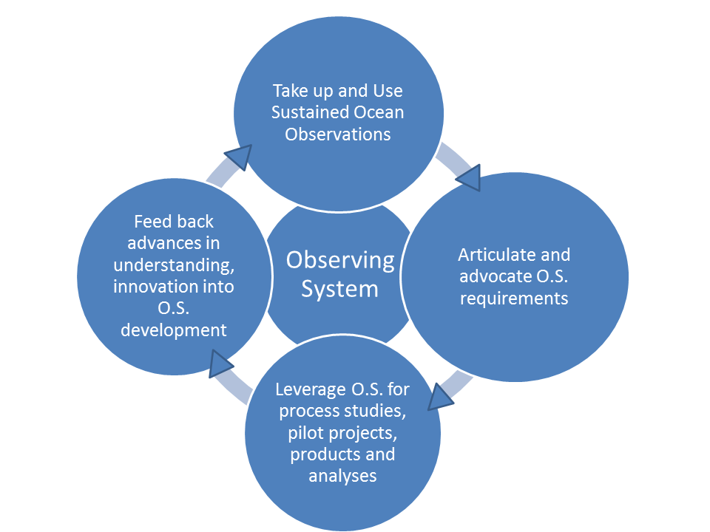

Figure 2. The important role research programmes play in sustaining and developing the observing system.

GCOS has an established relationship with WCRP, which is also a co-parent of the 3 GCOS expert panels (including OOPC). WCRP programmes were strongly involved in the development of the Ocean Observing System for Climate; Building on the World Ocean Observing Experiment, and Tropical Oceans Global Atmosphere Experiment, plans developed through OOPC and the CLIVAR programme. The research programmes were central in providing the impetus for sustained observations and advocating for what was needed. Since an observing system has largely been in place, and WCRP’s role has evolved, it is timely to reframe the relationship between research programmes and the observing system.

Given GCOS and WCRP are developing forward strategies; it is timely to consider how the two programmes will interact into the future to advance the climate observations and research agendas for the benefit of both.

For other GOOS delivery areas, such research partnerships are under development;
- Operational Services (GODAE OceanView)
- Multidisciplinary Climate applications as well as Ocean Health (e.g. IMBER, SCOR and SOLAS through GOOS BGC and Biology). Interactions with Future Earth are still in their infancy.

3.1.3. Partnerships for delivery on climate

Both GOOS and GCOS recognize that engagement and partnership with key actors in the value chain from observations to end users is critical in increasing the impact and visibility of the observing system, improving its sustainability. These key players include data systems, research and forecasting activities, and assessment and service delivery processes that add value to observations, and reach individual or policy users of climate observations - even those that may not be aware of the observations themselves.

The traditional strength of GCOS is the path from climate observations to the WCRP research community as primary users, to climate projections and IPCC’s Working Group I, informing UNFCCC’s global climate policy, with a focus on scenarios and mitigation of climate change. The GOOS community used this GCOS strength to bring visibility to the required ocean observations.

The climate landscape has changed and broadened, with growing interest (in the UNFCCC and elsewhere) in adaptation to climate change, and climate services based on seasonal-to-decadal time scale forecasts. That implies that GCOS needs to expand its partnerships - in some areas GOOS would be interested in accompanying that partnership development, and in some places GOOS might be able to take a leading role. This might be most true in climate services, where the timescales of forecasting are highly dependent on knowledge of subsurface ocean initial conditions.
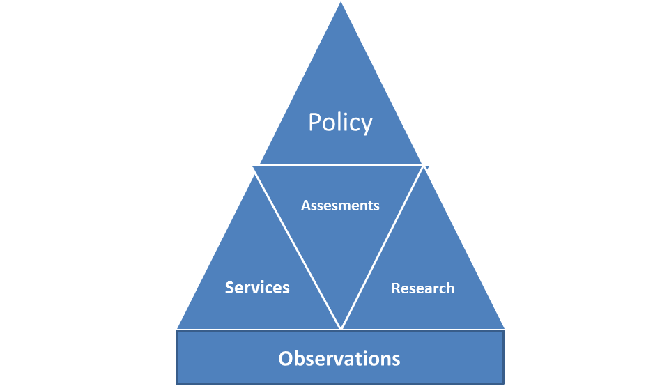Figure 3. The Observing system pathway to impact through Research, Assessments and Policy.
3.1.4. Space agencies engagement (CEOS, CGMS)

An area highlighted as potential area for greater collaborative engagement for GCOS and GOOS is with the Satellite programmes and agencies. GCOS has an extremely strong relationship with the Space Agencies through two mechanisms for Operational Satellites, the Coordination Group for Meteorological Satellites (CGMS); and Research based Satellite efforts, the Committee for Earth Observing Satellites (CEOS) which have a joint Working Group on Climate. The satellite agencies are enthusiastic supporters of the ECVs and dedicate significant amounts of funding to satellite missions and the delivery of datasets to meet ECV requirements.

GOOS traditionally has a weaker connection to satellite agencies, and could perhaps work with GCOS to strengthen this relationship, through e.g. the CEOS Plenary and SIT meetings. GOOS and GCOS could also enhance their cooperation to present a more integrated and comprehensive suite of requirements to CEOS/CGMS covering all ocean observations, for all purposes. This is an area where GOOS could benefit from the more recent experience of partnership of GCOS with the WG Climate.

The satellite agencies also have a multiplicity of bodies (“Virtual Constellations”) which coordinate satellite observations of specific ocean parameters e.g. SST, ocean surface winds, sea surface topography. These VCs are also informed in turn by the science teams for each of the parameters with which OOPC already has strong connections, and these various links could be further investigated.

Proposed ACTION: GCOS and GOOS leadership consult on their partnership strategies and identify the common objectives; and then make some decisions about lead/participate, who, how, resource requirements.

3.2. Advocating requirements for sustained observations:

While it is becoming apparent that GCOS and GOOS requirements setting are driven by slightly different aims, ultimately, we need to ensure we can map one onto the other. This is important to ensure that GCOS and GOOS work together effectively to advocate for sustained observations. It is particularly important for the stakeholders of GCOS and GOOS that the relationship between the two programmes and the observation requirements being advocated are understandable.

Separate discussions are focussed on the requirement setting to ensure there is a common understanding of the terms, definitions and goals of requirements, noting that
- For GOOS: Overarching motivation for articulating requirements for ocean observations for climate, ocean health and operational services: To motivate investment, and inform development of the ocean observing system.
- For GCOS: To advocate that observations of relevant variables (ECVs) meet climate user needs.
ACTION: Request GCOS-GOOS Secretariats work together to agree on approaches, terminology, and transparency in how the requirements from one relate to the other.

3.3. Regional development and Capacity Building

GCOS focus on adaptation and mitigation, and GOOS strategic priorities in capacity building, how do we leverage GCOS Regional Workshops, GCOS Cooperation Mechanism, and the efforts of GOOS Regional Alliances to broaden participation and improve the resilience of sustained observations? This is an area which could warrant particular discussion between GCOS and GOOS. A GCOS Task Team on Climate Adaptation has been established under TOPC.

Proposed ACTION: GCOS and GOOS Leadership to focus a future meeting on how the programmes might work together to advance regional implementation and capacity building.

3.4. Why should GCOS and GOOS work together?

A strong GCOS/GOOS relationship means GCOS benefits fully from the broader GOOS expertise and developments, and coordinated structures, including its influence on how ocean observations are implemented and performance tracked to advance the observing system. This helps to engage a strong community in GCOS. The GOOS mapping of users and consultation with the community means much more of the users and observing community is exposed to GCOS and can deliver to GCOS aims.

GOOS sees working with GCOS as the pathway to value through WCRP, IPCC WG1, UNFCCC policy on mitigation particularly; and we see potential and can help with our panel contacts with scientific community with other pathways: i.e. through research (PROVIA, IMBER, etc.), IPCC WG2, UNFCCC policy and Parties response on adaptation to climate change.

Building on the TPOS 2020 legacy, an area of potential strengthened engagement is into climate services - where oceans are in fact the dominant driver of the relevant timescales for ENSO; and the dominant source of predictability on seasonal and longer timescales. A common clear strategy between GOOS and GCOS to engage WMO and other climate service structures would strengthen the visibility of observations for these services, delivering to both GCOS and GOOS strategies.

GOOS has strong working level engagement with research community, e.g. CLIVAR, broader engagement through BGC (SOLAS), Biology (IMBER, etc.) and Also Policy though IPBES. Due to the importance of the ocean climate variability (e.g. ENSO) OOPC / GOOS can bring a new perspective into GCOS and increase its relevance for another climate user: climate services, particularly through projects such as TPOS 2020; and perhaps strengthen links into the Agrometeorological and climate services Standing Committee proposed under the WMO Commission for Services and Applications.

This paper highlights the complexity of connecting up synergies and opportunities at the interface between GCOS and GOOS at all levels. Indeed, the potential connections and opportunities to work together are broadening. Hence, GCOS and GOOS need to continue to work together at the Steering Committee to Steering Committee level and Director to Director, in addition to using OOPC as a broker.

Proposed ACTION: Regular communication established between GCOS/GOOS Directors (monthly), Chairs (quarterly/6 monthly?), and Steering Committees.

4. Co-parenting OOPC
As outlined in the opening section, both GCOS and GOOS programmes are evolving. For OOPC, this has meant that the demands on the panel have multiplied.

Firstly, GOOS has seen a major change in governance;

- Pre OceanObs’09, OOPC was the open ocean panel of GOOS, which delivered ocean requirements to GCOS.
- Post OceanObs’09, OOPC became the Physics Panel of GOOS, with Biogeochemistry and Biology sibling panels, while still having the responsibility of delivering climate requirements to GCOS.
Secondly, both GCOS and GOOS have roughly 1-1.5 technical staff for each of the expert panels, which means that levels of cross programme activity have increased.
These evolved and expanded, which has put pressure in particular on the panel chairs and secretariat. It is timely for GCOS and GOOS, as the main co-parents, to discuss how to guide, support and resource the panel to meet these needs.

This includes:

  - GCOS and GOOS to coordinate forward planning of deliverables and packaging of requests for input for efficiency.
  - In GCOS, sufficient time is allowed so that OOPC can consult with other GOOS panels on important decisions.
  - GCOS and GOOS to provide joint guidance on priorities.

As a joint panel between GCOS and GOOS, OOPC is the focal point for the development of the Sustained Ocean Observing System for Climate. However, in order to deliver to priorities set out in the GCOS Implementation Plan, OOPC has to work across many structures in GOOS. In addition, GOOS expects OOPC to take on tasks which may not be considered a priority from a GCOS point of view, such as engaging in operational services, ocean forecasting. This is a very broad scope, with many points of engagement, and a large coordination overhead for one panel;

GCOS has an expectation that panel members will take on particular roles (see GCOS Panel Member TORs, ECV Steward and GCOS IP Rapporteurs); however, these tasks need to be distributed across all of GOOS structures in order to get truthful and scientifically-sound input (3 panels, the Observations Coordination Group and GOOS regional Alliances).

An initial agreement between GCOS and GOOS Leadership outlined the following core priorities for the panel:

- Set and review requirements to guide the sustained ocean observing system, and advocate for implementation: broker guidance through two mechanisms based on existing mechanisms and available information:
  - GOOS Physics EOVs
  - GCOS Ocean ECVs (Needs additional input from GOOS BGC, BioEco panels and secretariats).
- Observing system evaluation and review: coordination of focused activities to develop and improve the observing system, improve integration (engaging WCRP, OceanPredict, JCOMM OCG, GOOS Regional Alliances, Other GCOS and GOOS panels)
- Guide, review observing system implementation through JCOMM OCG, Satellite Agencies, GOOS Regional Alliances.

Addressing additional priorities will depend on guidance from GCOS, GOOS, required membership on the panel and available resources (particularly staff resources). The prioritisation and resourcing of these additional task areas is under discussion.

- Priority 1: Expanding focus into coastal regions for
  - For GCOS regional implementation goals, Climate adaptation, underpin tracking of changes in ocean health.
  - Requires additional panel members, engagement from GOOS Regional Alliances, additional staff support.

- Priority 2: Improve delivery for Climate: developing multidisciplinary climate observing system requirements and establishing a mechanism for reviewing implementation.
  - Requires extra effort from other components of GOOS.
  - Additional OOPC staff support needed.

- Priority 3: Improve delivery for operational Services: expand to consider specific focus on delivery to operational services, engaging in WMO programmes.
  - Additional staff support needed.
  - Currently OOPC Staffer working informally with colleagues in WMO Obs department and more broadly within WMO.
  - OOPC also prioritising engagement with GODAE OceanView for observing system design.
  - Consider negotiating a more formal arrangement with WMO Observations department.

- Priority 4: Improve delivery to Ocean Health
  - Provision of underpinning environmental information to meet needs.
  - (Already involved in multidisciplinary projects).

Proposed ACTION: GCOS, GOOS SC to review and agree proposed priorities for OOPC; GCOS/GOOS Directors to act on advice considering the resourcing required (panel expertise, financial and staffing support)

Proposed ACTION: GCOS and GOOS Directors to discuss and agree on guidance to the OOPC before panel are consulted (e.g. expectations of panel members, packaging of tasks), recognise that guidance from GCOS has broader consequences to other components of GOOS.

Proposed ACTION: GCOS gives OOPC sufficient time to consult with other panels when making important decisions.

Proposed ACTION: GCOS and GOOS work together on the forward scheduling of meetings, tasks and deliverables to ensure they are complementary, identify efficiencies and minimise schedule crunches.

5. OOPC Secretariat Support.

Supporting OOPC, engaging across GCOS; and engaging across GOOS (to deliver to Climate and Operational applications), is too big a job for 1 secretariat staff. Efforts are being made to seek additional resources. In the meantime, GCOS and GOOS directors are looking for ways to improve guidance, streamline requests, and agree on priorities and better support the OOPC and its staffer.

Recommended approach to distributing load:
- GOOS Identify a second GOOS staffer (from one of the other panels) to formally engage in GCOS discussions (i.e. seen as part of the OOPC secretariat from a GCOS Perspective).
- Seeking a second staffer (possibly a JPO) to work with the OOPC Secretariat to look after GOOS Physics, support engagement in operational services. The OOPC Staffer can then focus more on leading in engagement on climate, and in operational services engagement.
- Advice or suggestions of other solutions also welcome.

Both GOOS and GCOS should bear in mind he very heavy load being imposed both on OOPC and its support staff. This will require that priorities are identified between them for the work to be undertaken by OOPC, to be set between S/C, Directors and other staff. This is not an unusual situation for any organisation and provided that it is recognised that prioritisation is needed, consideration of the overall workload should not be a major stumbling block for cooperation.

Proposed ACTION: Request GCOS and GOOS Directors seek additional staff support for OOPC activities.
Decision: To recognise the conclusions of the chairs, and request the GCOS and GOOS Directors provide joint management to OOPC, ensuring the panel has the necessary guidance and support it needs to perform.

