Action Item ATTL-10: GRUAN
As part of the Task Force Lightning (TTL) meeting of the WMO in Greenbelt, Maryland in February 2019, one idea that developed was to use the GCOS Reference Upper-Atmospheric Network (GRUAN) to enhance the efforts to establish long term climate measurements of global thunderstorm activity.
The global Earth system between the surface and the ionosphere can be described as a Global Electric Circuit (GEC) (Markson, 2007) with observable atmospheric currents, electric fields, conductivity, potentials and a capacitance (see figure).
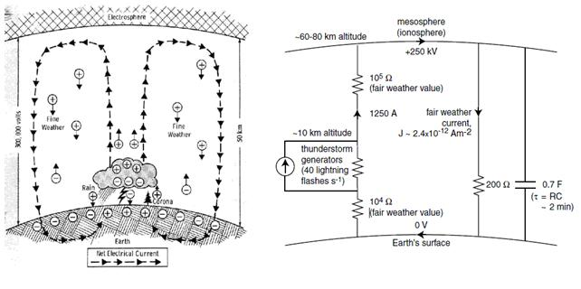
Thunderstorms (~1500 active storms around the planet) drive currents of around 1 Ampere per storm (Mach et al., 2011) upwards above thunderstorms to the ionosphere, where the currents are spread around the globe, flowing back to the surface in fair-weather regions. In these fair weather regions we continuously measure the conduction currents (~2x10⁻¹² Amperes) and vertical electric fields (~130 V/m) produced by global thunderstorms around the globe (Rycroft et al., 2012). By integrating the E-field with height (using balloons or planes) we get the Ionospheric Potential of ~250kV. This parameter represents the globally integrated electrical activity in global thunderstorms, and hence supplies a global geo-electric index that can be monitored easily over long periods of time. Unlike the global lightning observations that depend on many sensors, satellites, and different detection efficiencies over time, the global electrical activity can theoretically be monitored by a single absolutely-calibrated sensor placed at a single location on the Earth.
As part of the WMO task force, we would like to propose using the GRUAN sites for regular ionospheric potential measurements using small E-field sensors that can be attached to regular radiosonde balloons. Only a few GRUAN sites would be needed to get a good estimate of the global atmospheric electrical activity (on a daily basis) and to monitor these changes over time into the future. And as mentioned above, these measurements do not have the problems of global lightning observations. Furthermore, they represent the activity of ALL electrified clouds, and not only those with lightning. The reason for focusing on the "ionospheric potential" measurement is mainly to get away from the polluted boundary layer, where aerosols impact the ground measurements of E-fields and currents through changes in local atmospheric conductivity. Having measurements in the free troposphere will provide the best conditions for monitoring the global circuit variability and future trends.
We propose and initial field campaign launching balloons simultaneously from 3-5 GRUAN sites, either a few times a day, or once a day during a month or two. These balloons would carry E-field sensors that would be identical for each launch, either built by researchers, or purchased commercially. The sensors would be initially financed via research projects, but if extended to regular daily measurements, other sources will need to be found. If the campaign is successful, we would propose including regular E-field soundings in future GRUAN launches on a regular basis (once per day, once per week).
Reference:
Mach, D.M., et al., 2011, JGR, 166, doi:10.1029/2010JD014462.
Markson, R., 2007, BAMS, DOI:10.1175/BAMS-88-2-xxx.
Rycroft, M.J., et al., 2012, JASTP, 90, 198-211, http://dx.doi.org/10.1016/j.jastp.2012.03.015.

