WORLD METEOROLOGICAL  ORGANIZATION |  | INTERGOVERNMENTAL  OCEANOGRAPHIC COMMISSION

Report from 1st Meeting of the Task Team
GCOS Upper Air Network (TT-GUAN-1)

Lindenberg, Germany
5th – 6th December 2017

GCOS-xxx

UNITED NATIONS  ENVIRONMENT PROGRAMME |  | INTERNATIONAL COUNCIL  FOR SCIENCE

Table of Contents

1. Opening of the Meeting 3
2. terms of Reference & Expectations for the meeting 3
3. GCOS Upper air network (GUAN) 3
4. National and User view on GUAN (SWOT Analysis) 4
5. Action Items from GCOS IP (2016) 7
6. Items raised during the meeting 8
7. Work plan (2018 and 2019) 8
8. AOB 8
9. Closure of meeting 8
Annex 1: Agenda 9
Annex 2: Terms of Reference 11
Annex 3: Report of network meeting ISPRA 2014 14
Annex 4: SWOT analysis for GUAN (Summary from meeting) 22
Annex 5: List of Participants 23

Opening of the Meeting

The meeting was opened with a welcome to all participants from Dr Franz Berger, Director of the Lindenberg Observatory.

Peter Thorne agreed to be the meeting chair and welcomed everyone to the meeting.

Tim Oakley, GCOS Secretariat, welcomed everyone on behalf of WMO and GCOS, introduced Caterina Tassone and Valentin Aich from the GCOS Secretariat and thanked all participants for taking the time to attend the meeting and take an active role in this Task Team.

All other members of the task team introduced themselves. The list of participants can be found in Annex 5.

The agenda (Annex 1) was adopted.

terms of Reference & Expectations for the meeting

Tim Oakley introduced the Terms of Reference for this task team, following the decision of the GCOS Atmospheric Observations Panel on Climate (AOPC), which was as follows:

AOPC-22 (Exeter, UK, March 2017) agreed on the creation of a dedicated task-team to deliver progress upon a number of actions in the GCOS Implementation Plan (GCOS 200) related to the operation and monitoring of the GCOS Upper Air Network:
• Reviewing the network requirements;
• Assessing and documenting the benefits of meeting stated requirements;
• How it contributes as a baseline network in the tiered network framework with GRUAN and the comprehensive network.

The Terms of Reference (TOR) is given in Annex 2.

The expectation of the meeting was to review the actions from the GCOS Implementation Plan (2016) as detailed in the TOR and agree a work-plan to address those parts of the actions within the remit/capability of the task team.

GCOS Upper air network (GUAN)

Tim Oakley presented an overview of the GUAN, with a focus on its current requirements, the performance of the stations and the challenges.

Peter Thorne presented a summary of the discussions and the recommendations arising from the GCOS network meeting held in Ispra, Italy (2014), which considered amongst other items the requirements of the GUAN and the GCOS Surface Network (GSN) and proposed how these networks, both requirements and management, could be changed in the future.

An abridged version of the Ispra meeting report is available in Annex 3

National and User view on GUAN (SWOT Analysis)

This agenda item captured national and user perspectives on the GUAN which were then used to provide a summary of perceived Strengths, Weakness, Opportunities and Threats (SWOT) for the network. The key points from each of the presentations were as follows:

Hiram Escabi (US National Perspective)

NWS's position on GUAN at the present time is GUAN requirements does not affect the 102 Upper Air Stations that are managed by NWS. There are no special polices or procedures for those GUAN stations that are part of the NWS upper air networks. Of the 102 stations managed by NWS 22 stations are GUAN identified. Again, these stations have no special guidelines as GUAN sites. All NWS upper air stations are managed by this agency's policies and directives. Any new requirements on balloon heights will impact agency funding profiles for upper air observations. Their current balloons are qualified as 26 and 20 kilometer height balloons. NWS launches 74,460 balloons and radiosondes yearly.

Richard Querel (New Zealand National Perspective)

Kevin Alder, Manager Meteorological Data Services, New Zealand MetService, offered the following points when asked about MetService’s perspective of GUAN and how it applies to their operations:

- From what I understand, GUAN was supposed to provide addition rigor and QC at nominated stations participating in the programme. In more recent times, technology and reliance on vendors’ ground station systems has taken over what was previously a manual process, especially now with the full flight data being encoded and distributed in high resolution BUFR data. These systems have been implemented at all stations, not just GUAN sites.
- I’m not aware of any new guidance that takes into account the changes in automation and ground station equipment. Guidance should be updated to take into account the changes in technology.
- Perhaps there is little understanding of what differentiates a GUAN station from a standard station – I really didn’t know the difference and had to do a reasonable amount of research in order to understand why GUAN was implemented.
- The observation programmes are being dictated by national requirements rather than the international obligations. This is the case in NZ, where we do not use the larger balloons required to achieve the required target heights. Similarly in Australia too, I believe.
- Similar to (4) above, financial pressures have led to the closure of 1 GUAN station (Chatham Islands) and the once a day sounding at Raoul Island.
- There is no ‘audit’ of GUAN stations, to show that stations are following the rules. Centres receiving the data have to trust that the programme each station is being performed correctly.
- The near real-time monitoring results for stations are extremely difficult to find. While QC data are published through portals such as eucos.dwd.de, these are generally very difficult to find, and need to be better publicised. The monitoring is really useful, especially for checking to see if the data are getting to the modelling centres, and independently and objectively verifying that there are no significant issues with the programme.

Marc Schroeder (DWD Satellite user perspective)

At CM SAF GUAN data is currently used for the evaluation of the CM SAF ATOVS product. The driving decision for this was the perception of superior quality, long-term perspective, reasonable number of stations, launch frequency and global distribution. In principle spatio-temporal coverage and long-term perspective are key advantages of GUAN (if consistently implemented).
For the validation of satellite based CDR stations with data coverage since the 70s are optimal. More relaxed requirements can be defined based on launch times of more advanced instrument series in later years.
Access to quality controlled and bias corrected data is another optimal requirement. Easy to find evidence on quality, including an indication of the degree of stability and homogeneity are required as well. Optimally, robust uncertainty estimates are provided along with the data.
For satellite cal/val ideally two radiosondes are launched collocated with the satellite overpass (Calbet et al., 2017, AMT). During discussions at the meeting it was noted that an implementation of adequate launch schedules, its global management, and the decision on giving priority to a specific satellite are not very practical. If not collocated with satellite overpasses, the number of collocations is a key aspect during validation. Then, quantifying the impacts of collocation uncertainty requires specific attention.
It was proposed to (centrally) apply the GRUAN processor to data from GUAN stations. At the start this can be done in a forward looking mode. Ideally dedicated reprocessing activities can be implemented at a later stage. To allow GRUAN processing but also for the general purpose of climate monitoring raw data with adequate metadata should be archived. Cloud cover is a useful piece of metadata that would greatly increase the potential utility for satellite applications and that for manual launch stations is possible at almost no additional cost.
It is a GEWEX water vapor assessment G-VAP recommendation to include a tropical land station (South America, central Africa), originally directed towards GRUAN but also valid for GUAN. Data from small island stations are considered to be useful because over open oceans hardly any ground truth is available.
Tim Oakley (UK Met Office National perspective)
Strengths
A global network ensuring common practices are shared across regions, providing a method to benchmark national performance with other similarly funded Members.

A strong Brand – everybody knows that GUAN is important (even if they don’t know why it is important) – or at least everybody who cares about climate observations.

Provides an underpinning standard against which other national practices can be compared. GUAN operators know how to fly R/S consistently well and so can act as a trainer for others.

Weaknesses
Uninformed Network Managers often quote the MVP (minimum viable product) as being easy to achieve, forgetting the MVP is there for Members who struggle to operate networks rather than those members with more resources.

Poorly performing stations devalue the GUAN Brand as they are not removed from the official network [also a threat]

The operators of the GUAN work in relative isolation and lack the opportunity to share best practice or ideas on how the operating practices could be improved.

Some people may have forgotten what the G in GUAN standards for! GCOS is important but profile may not be as high as perhaps it should be.

Opportunities
The national interest in the continued monitoring of the climate to ensure we understand the causes and impacts of climate change should enable (continued) access to funding sources.

Access to best practice mechanisms shared across the GUAN community could lead to improvements in operational practices

Healthy competition to supply radiosonde equipment to GUAN stations should ensure a healthy technology supplier market.

Threats
The drive towards more timely data, for HiRes NWP, could compromise the drive to ensure GUAN flights reach as high a level as possible (now that total message generation before transmission for BUFR format). That is to say that the need to deliver data in a timely manner outweighs the need for delivering data to high levels. Although the whole profile can be transmitted later partial transmission carries an obvious risk that the transmission of the remainder is not seen as mission-critical.

Manual observations are perceived as expensive and so cutting back on GUAN stations may be seen as an effective way of reducing operational costs. Radiosondes are uniquely vulnerable as they tend not to be recovered whereas satellites and remaining in-situ tend to last much longer between replacements.

GRUAN is now seen as our primary climate monitoring network and so continued investment in GUAN is undermined as GUAN is not GRUAN. This is particularly so as currently there is nothing that substantially scientifically distinguishes a GUAN site from the remainder of the GOS sonde network.
Ruud Dirksen (DWD national perspective)
Lindenberg Observatory is GUAN/GRUAN site, but not a direct data user. The German GUAN sites are Lindenberg; Neumayer and Ny Alesund.

GUAN data are not used for climate analysis but rather mainly used for NWP. The grid of GUAN sites is too coarse for regional weather forecast. Additional observations are needed by DWD.

Globally, the issue of data continuity in developing countries inhibits the effective usage of GUAN data. Equally, this is an opportunity in that a reinvigorated GUAN may permit a greater degree of sponsoring/mentoring by developed countries.
Bruce Ingleby (ECMWF user perspective)
For NWP GUAN is just considered to be part of Global Radiosonde Network. No special treatment is given to GUAN sites in an operational sense. At the same time, it is recognised that the global radiosonde network would be worse-off without GUAN. However, radiosonde type is a better indicator of quality than is GUAN membership. In some countries “better” radiosondes are used for GUAN. There are particularly problems where radiosondes continue to track with radar but no pressure sensor. Further details of ECMWF’s analysis are given in ECMWF Tech Memo 807 (2017).

- Some good radiosondes are poorly documented (eg LMS6)
- There are avoidable height errors (biases) for some stations
- Treatment of radiosonde drift gives stratospheric analysis improvement + some benefit to tropospheric forecast at day 5
- Radiosondes still important for NWP (esp. in NH). Use as reference data.
  - Vital for climate reanalysis (especially pre-GPSRO).
- Moving launch times: in principle not a problem for assimilation
  - Some issues, e.g. verification
- Radiosonde burst height
  - Difficult to quantify the importance; ECMWF not ‘spreading the influence’ of radiosondes as far as it used to (need to treat bias separately)

The meeting discussed the various presentations and then agreed on an overall SWOT for the GUAN and this is given in Annex 4

Action Items from GCOS IP (2016)

It was agreed that the relevant actions from the GCOS IP had already been discussed under earlier agenda items and thus further discussion on the GCOS IP was not required.

Implement vision for the future of GCOS Upper-Air Network operations (A13)

Discussions under this agenda item focused on: the vision of GUAN; its role as part of a tiered-network (Comprehensive; Baseline; Reference); the benefits for global, regional and national requirements and what a future GUAN should be (if at all). The meeting agreed on the following high-level statement as a vision for GUAN.

- Continuing under its current requirements is not a long-term option
- New focus should be on a guaranteed quality of observational data, according to updated requirements
- It should be a subset of the comprehensive network based on quality assurance rather than a fixed network of stations. Adopting a tiered-network approach (Comprehensive-GUAN-GRUAN), as described by GAIA-CLIM (Thorne et al., 2017)
- Actively managed through a lead-centre, with a certification process, real-time monitoring and validated station list for the user community
- Process to identify gaps in global/regional networks, both in data sparse areas and least develop countries, to allow targeted support projects, using relevant cooperation and funding mechanisms (i.e. GCM, GCF, national bi-lateral programmes).

Evaluation of benefits for the GCOS Upper-Air Network operations (A14)

As this action is very much related to A13, much of the discussion had already taken place under the previous agenda item. It was agreed that a literature review should be undertaken by all members of the task-team for studies on the benefits of number of daily soundings; maximum height of measurements; scheduling and remote locations. The meeting also agreed that AOPC should be requested to assist in the literature review.

For the later point (remote locations), a number of NWP studies have already highlighted the significant value of remote radiosonde stations.

It was agreed that the stated requirements in the Ispra meeting document (see Annex 3) would be used as the starting point of a future GUAN.

Transition to BUFR (A5)

Bruce Ingleby gave a presentation on the current status of the transition to BUFR for radiosonde systems, from the NWP perspective. It was very evident that there were a number of issues and challenges which were impacting on the both the usefulness and quality of the radiosonde observations. Comparing TEMP and BUFR data has shown that there can be offsets (of 0.05 or 0.1 K) due to rounding in TEMP coding (which varies with radiosonde type and software) and details of the decoding. Bruce suggested that the 2019 radiosonde intercomparison should include, where possible, generation of ‘operational’ TEMP and BUFR messages – to check for coding issues like this. There is evidence that some radiosonde ascents are ‘lost’ in that they never make it onto the GTS, this seems to be a particular problem in Africa. The progress towards high-resolution reporting is very drawn out but about 250 stations (30% of the total) are now providing high vertical resolution (see https://software.ecmwf.int/wiki/display/TCBUF/Data+availability). However it seems that some countries have no resources to migrate.

The meeting agreed to communicate the points raised from the presentation within all communities, particularly WMO.

Retain original measured values for radiosonde data (A17)

The meeting agreed that retaining the original measured values, at least on-site, was an important requirement of both a reference and baseline stations, and really should be the case for all stations undertaking radiosonde measurements.

Ruud Dirksen agreed to draft a technical note on the benefits of retaining raw (level-1) data. This would then be communicated further within WMO (e.g. CIMO and HMEI)

Items raised during the meeting

No further items were raised for discussion.

Work plan (2018 and 2019)

The following work-plan was agreed:

- Meeting report to include draft SWOT and Vision (High-level statement), key points for individual presentations. Final version of meeting report will provide the agreed version of SWOT & Vision.
(Lead Tim Oakley – Target Date Jan 2018)
- ISPRA meeting document – Stated GUAN requirements will be taken as a starting point of a future GUAN. (Included as an Annex in the meeting report)
(Lead Tim Oakley – Target Date N/A)
- Literature review for studies on the benefits of number of daily soundings, maximum height of measurements, scheduling, remote locations etc.
(Lead GCOS Secretariat to coordinate, and all/AOPC to contribute – Target Date Feb 2018)
- Review (3) above, summarize and identify gaps. Articulate experiments that might close the gaps in scientific understanding.
(Lead ?? – Target Date ??)
- BUFR (A5). Note the report of Bruce Ingleby, and support the resolution of issues identified.
(Lead All Members – Target Date Ongoing)
- (A17) – GRUAN technical document about benefits of retaining raw data (Ruud Dirksen). Approach CIMO. Approach HMEI (GCOS Secretariat)
(Lead Ruud Dirksen, GCOS Secretariat – Target Date ??)
- Update of (2) for draft specification for GUAN-II
(Lead ?? – Target Date ??)
- High-level proposal for a redefined GUAN to be presented to WMO Congress (May 2019). Document would need to finalized by Jan 2019.
(Lead tba – Target Date tba)
- Detailed proposal for a redefined GUAN to be presented to WMO EC (2020).
(Lead tba – Target Date tba)

AOB

There was no further business raised by the participants.

Closure of meeting

Peter Thorne thanked the local hosts and DWD for their excellent hospitality for the meeting. The provision of snacks and drink during the meeting was most generous. The tour of the Lindenberg facility, in particular the work of the GRUAN Lead Centre, was very informative.

The meeting was closed at 17:00 on the 6th December 2017.

Annex 1: Agenda
Day 1: Tuesday, 5th December 2017
Time |  | ITEM | N° | Presenter | Targeted outcome
09:00–09:20 | Opening | Opening of the Meeting | 1.
 |  | Welcome | 1.1 | Peter (Meeting Chair)
 |  | Introductions | 1.2 | All
 |  | Adoption of Agenda | 1.3 | Tim
 |  | Conduct of the Meeting & Local Information | 1.4 | Tim and Ruud
09:20–09:40 |  | Review Terms of Reference/ Expectations for the Meeting | 2. | Tim
 |  | Expected outcome of the meeting | 2.1 |  | Agreed expected outcome
09:40–10:00 |  | GUAN | 3.
 |  | Background, Requirements and Status | 3.1 | Tim
10:00–10:20 |  | Recommendations from ISPRA 2014 | 3.2 | Peter
10:20–10:40 |  | Coffee Break
10:40–12:00 |  | National and User view on GUAN (SWOT Analysis) | 4.
 |  | NWS (USA) | 4.1 | Hiram
 |  | NIWA (New Zealand) & GRUAN | 4.2 | Richard
 |  | NWP (ECMWF) | 4.3 | Bruce
 |  | Satellite (DWD) | 4.4 | Marc
 |  | CMA (China)/Met Office (UK)/DWD | 4.5 | Tim or Ruud
12:00–13:00 |  | Lunch
13:00–14:30 |  | Tour of Lindenberg Observatory (Weather permitting)
14:30–15:30 |  | Continuation of session 4  Summary of session 4 | 4.6 | All | Key points
15:30–15:50 |  | Coffee Break
15.50-16.00 |  | Action Items from GCOS IP (2016) | 5.
 |  | GCOS Implementation Plan | 5.1 | Caterina
1600-17.30 |  | Implement vision for the future of GCOS Upper-Air Network operations (A13)  What is the vision?  Higher data quality.  Integration with other networks (i.e. GRUAN).  Aligned with WIGOS framework. | 5.2 | All | Summary of the key points.
17:30 |  | End of day 1

Day 2: Wednesday, 6th December 2017
Time |  | ITEM | N° | Presenter |  | Targeted outcome
09:00–10:30 |  | Action Items from GCOS IP (2016) cont
 |  | Evaluation of benefits for the GCOS Upper-Air Network (A14)  Availability; Scheduling; Burst Height; Required Quality | 5.3 |  |  | Summary of the key points.
10:30–10:50 |  | Coffee Break
10:40–11:30 |  | Transition to BUFR (A5) | 5.4 |  | Summary of the key points.
11:30–12:00 |  | Retain original measured values for radiosonde data (A17) | 5.5 |  | Summary of the key points.
12:00–13:00 |  | Lunch
13:00–14:30 |  | Items raised during meeting | 6
 |  | Review and discuss each point
14:30–15:30 |  | Work Plan (2018 and 2019) | 7
15:30–15:50 |  | Coffee Break
15:50–16:30 |  | Continuation of item 7 |  |  | Draft Work Plan
16:30–16:50 |  | AOB | 8
16:50–17:00 |  | Closure of meeting | 9
17:00 |  | End of Task Team meeting

Day 3: Thursday, 7th December 2017 (GCOS, GRUAN and GAW)
Time |  | ITEM | N° | Presenter | Targeted outcome
0930 - 1630 |  | Discussion Points
- Walk through GRUAN LC at work
- Current projects
- Work prioritisation and processes
- Station/Instrument certification
- Relevant actions of ICM-9
- ICM-10 planning
- GRUAN and GAW
- GRUAN Management and communications with AOPC
- Next CIMO Radiosonde Intercomparison

Annex 2: Terms of Reference

Task Team on the GCOS Upper Air Network (GUAN)
Background
AOPC-22 (Exeter, UK, March 2017) agreed on the creation of a dedicated task-team to deliver progress upon a number of actions in the GCOS Implementation Plan (GCOS 200) related to the operation and monitoring of the GCOS Upper Air Network:
• Reviewing the network requirements;
• Assessing and documenting the benefits of meeting stated requirements;
• How it contributes as a baseline network in the tiered network framework with GRUAN and the comprehensive network.

Membership

Chair (If no suitable candidate, agreed on a meeting by meeting basis)
AOPC Expert – Peter Thorne (peter.thorne@nuim.ie) – Maynooth University (Ireland)
GRUAN Exepert – Richard Querel (Richard.Querel@niwa.co.nz) – NIWA (New Zealand)
NWP Expert – Bruce Ingleby (bruce.ingleby@ecmwf.int) – ECMWF (UK)
CBS/National Expert – Hiram Escabi (hiram.escabi@noaa.gov) – NWS (USA)
Satellite Expert – Marc Schroeder (Marc.Schroeder@dwd.de) – DWD (Germany)
National Expert – (Large GUAN contribution – China, Japan, Russia?)
GCOS Network Manager (Secretariat support) – Tim Oakley (toakley@wmo.int) (UK)
GCOS AOPC Scientific Office (Secretariat support) – Caterina Tassone (ctassone@wmo.int) (Switzerland)
CIMO expert team on upper air systems representative – Later meeting, if required
HMEI Observer – Later meeting, if required

Terms of Reference
(as approved by AOPC-22 and email xx/xx/2017)

Scientific charge
- Complete actions A13 and A14 in the GCOS IP on the GUAN vision, and start the implementation of any resulting changes to GUAN. As part of this process document the benefits of GUAN.
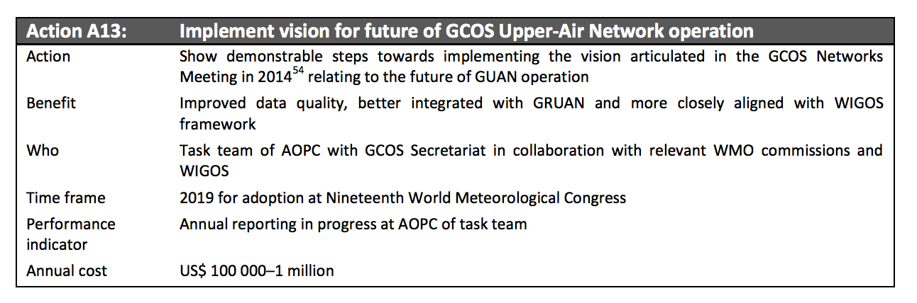
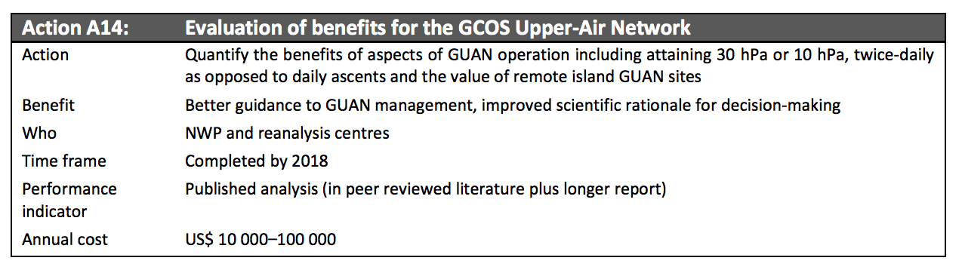

- Specifically, review and update the requirements of the GUAN, in terms of:
  - Availability
Currently the GUAN membership is primarily a result of location, historical records and a commitment by WMO Members. Management is primarily passive, informing and encouraging, which means that underperforming stations are rarely censured. The task team should consider whether an alternative metric or set of metrics should be used in future. This consideration should extend to timeliness and vertical resolution considerations.
b) Scheduling
GUAN radiosondes are currently launched at 00 and / or 12Z for historical reasons. The task team should assess from the range of climate application areas (trend detection, satellite cal / val, process understanding etc.) whether a change to this guidance is required. This should be done in collaboration with CBS Expert-Team in Surface Based Observations.
c) Balloon burst height
GUAN radosondes at many of the stations do not meet the stated heights required in GCOS-144. Analysis is required to assess the cost-benefit basis of making regular ascents to the height currently stipulated.
d) Required quality.
Should GUAN sites launch radiosondes that meet certain quality criteria? If so, how should these criteria be assigned and assessed to ensure a robust and fair system?

- Monitor the use of BUFR reporting and the associated metadata for GUAN GCOS IP A5
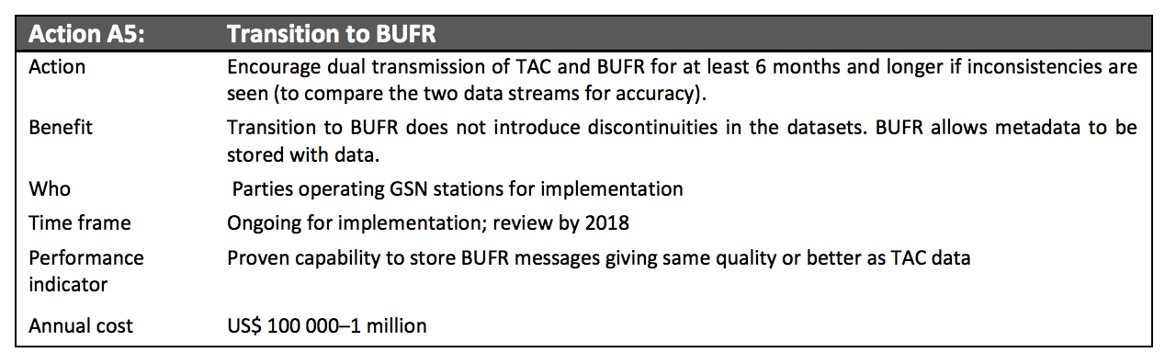

- Document requirements and propose a process for retaining original radiosonde measurements (raw data) as detailed in GCOS IP A17.
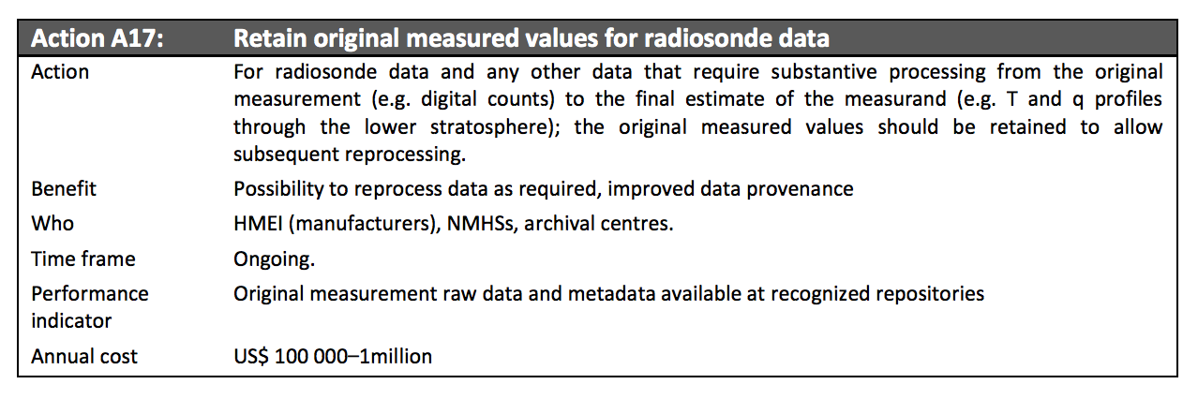

Modus operandi
- The task team shall exist for an initial period of two years.

- The task team shall work primarily remotely, facilitated by GCOS secretariat. It is expected that an initial ‘in person’ meeting will be organized to discuss and agree the work-plan and deliverables, further meetings will be decided as required.

- Within 3 months of the initiation of the task-team a detailed work plan and deliverable will be agreed.

- The task team chair shall be expected to report annually on progress to AOPC by means of a brief written report and, if support available, verbal reporting in person.

- The task team shall be expected to lead the production of a final report which may form the basis for any modifications recommended by AOPC to GUAN’s future operation.

Background documents
The Global Observing System for Climate: Implementation Needs, GCOS-200, https://library.wmo.int/opac/doc_num.php?explnum_id=3417

Status of the Global Observing System for Climate - Full Report, GCOS-195, http://www.wmo.int/pages/prog/gcos/Publications/GCOS-195_en.pdf

Workshop on the review of the GCOS Surface Network (GSN), GCOS Upper-Air Network (GUAN), and related atmospheric networks, Ispra, Italy, April 2014, GCOS-182, http://www.wmo.int/pages/prog/gcos/Publications/gcos-182.pdf

Guide to the GCOS Surface Network (GSN) and GCOS Upper-Air Network (GUAN) (2010 Update of GCOS-73), GCOS-144, http://www.wmo.int/pages/prog/gcos/Publications/GCOS-144_en.pdf

Annex 3: Report of network meeting ISPRA 2014

Workshop on the Review of the GCOS Surface Network (GSN),GCOS Upper-Air Network (GUAN) and related atmospheric networks. 7 – 8 April 2014, JRC, Ispra, Italy - June 2014 (GCOS – 182)

1. Introduction
Following the recommendation from the eighteenth Session of the Atmospheric Observation Panel for Climate (AOPC), which is jointly sponsored by the Global Climate Observing System (GCOS) and the World Climate Research Programme (WCRP), a workshop was arranged to review the requirements of the GCOS Surface Network (GSN) and Upper-Air Network (GUAN) 20 years after their establishment, in the light of changes in both technology and data needs, and to consider general matters concerning the designation of networks. The workshop also discussed the role of related networks such as the GCOS Reference Upper-Air Network (GRUAN) and the Global Atmosphere Watch (GAW). It was held on 7 and 8 April 2014 at the European Commission Joint Research Centre (JRC) in Ispra, Italy, preceding the nineteenth session of the AOPC.

The meeting included experts for specific operational networks, monitoring and archive centres, and data users. Chaired by Phil Jones, participants discussed the design, scientific principles, performance and use of data from the GSN and GUAN, and their roles in relation to the comprehensive surface and upper-air networks.

The meeting began with a series of presentations and accompanying plenary discussions.

These highlighted a number of issues that were identified and discussed further within breakout groups during the rest of the first day and the whole of the second day. The breakouts reported back to a plenary meeting during the second day. The first breakout session constituted a pair of breakouts which considered the future of the GUAN and GSN networks respectively. The second set of breakout groups discussed Data Rescue and the network of networks (often termed system of systems) concept.

2. GCOS Upper-Air Network (GUAN)
Breakout discussions were informed by the pair of earlier presentations in plenary given by Peter Thorne and Tom Peterson which, whilst agreeing that maintaining GUAN as it stood was not desirable, had given very different prescriptions as to how to address the issue.

Participants welcomed these presentations, which had clearly been given considerable thought and preparation. Plenary discussions had also highlighted other salient points, which naturally informed the breakout discussions.

Peter Thorne had presented a view arising from participants at the 6th GCOS Reference Upper-Air Network (GRUAN) Implementation and Coordination Meeting (ICM-6)1. This called for strengthening GUAN together with a clear distinction from the soundings typically performed in the WMO Global Observing System (GOS) as a whole in terms of the data and metadata delivered and the active monitoring of performance. This would make it intermediate between GRUAN and GOS operations.

Tom Peterson had suggested that GUAN had exceeded its useful lifetime and advocated against further investment of time or resource on scientific grounds. He argued that radiosondes were an expensive, old technology and that it was possible that sondes would be seen as redundant in the medium term with technological advances and increased profile data from commercial aircraft operations and remote sensing (both ground- and spacebased). He also raised the issue of environmental littering that is inevitable with single-use consumables. Finally, he had highlighted the danger when trying to encourage countries by supplying sondes that this might have the opposite effect, leading to dependency on external funding of supplies to continue operations.

In plenary discussions arising, the point was made by participants that at the current time, radiosondes have the highest per-observation impact on NWP performance in Observing System Experiments (OSEs). It was not foreseen that this situation was likely to change, at least in the near-term. On the other hand, a recent cost benefit study based on forecast sensitivity to observations does not give radiosondes a very high impact compared with aircraft profiles.

Participants discussed targeted observations. It was stressed that launching sondes only at special situations in future would only work if one could be confident that the forecasting system captured every severe weather event. Currently, this is not the case. Furthermore, it would have deleterious impacts upon long-term climate record continuity, if launches were solely to occur ‘on demand’. Finally, training of operators is an essential factor for measurement quality and might be a reason to maintain regular soundings. In discussions with GRUAN site operators, the desire to regularly make measurements to keep producing high-quality measurements has been highlighted by station operators.Regarding the statement not to wait 10 to 15 years, knowing that the technology was likely to run out, Adrian Simmons, highlighted the need to fill the gaps in observations until new technologies are in place and proven. Furthermore, overlapping measurements were seen as one of the key GCOS principles.

In conclusion, while recognizing that a robust discussion had been healthy and nothing necessarily could or should last forever, the general feeling of plenary had been that modifying GUAN was the preferable course. This was also the strong consensus position of the breakout group members. The breakout agreed that the high-level characteristics of a modified GUAN which would be pursued were to be as follows:

• GUAN should be about coverage, but also about data quality.
• GUAN data should be actively monitored for quality and adherence and that GUAN certification/designation should be applied to sites that meet GUAN requirements.
• GUAN data are defined by their measurement properties, so that they can be used with some confidence by data analysts and users, including for, but not limited to, climate analysis.

These reflect a realignment of purpose. In a nutshell GUAN ‘membership’ and data would mean something to the end-user be they intending to use the data for climate or for more near-real-time applications. GUAN measures would be able to be used with some confidence that they are likely to be fit for purpose. Such realignment requires substantive changes to GUAN operations and guidance.

Participants recognized that such changes would require consideration by other relevant bodies within both WMO and GCOS before they could be enacted. What follows are highlevel initial recommendations. It is fully expected that these will be modified following discussion and consultation with relevant WMO Technical Commissions and programmes such as the WMO Integrated Global Observing System (WIGOS) prior to adoption.

2.1 Measurement Requirements for GUAN
Commensurate with the WMO regulatory practices, the breakout group considered requirements under two classes: “shall” and “should” (henceforth, these are italicized to highlight their intended meaning is commensurate with this guidance). The measurement shalls reflect minimum requirements which, if not met, would be deleterious to science applications and, therefore, below which it is not possible to claim GUAN status. Measurement shoulds reflect possible additional and relatively inexpensive capabilities which, if met, would substantially increase the value of the data to a broad range of users. GUAN stations are strongly encouraged to implement both all the shalls and all the shoulds.

GUAN operators shall
• Report full profile measurement in BUFR format, including full metadata (model, batch, ground checks, surface pressure etc.).
• Retain the raw data counts to allow future reprocessing. (The raw data is supposed to be archived locally; at a later stage a more routine distribution of these data might be implemented.)
• Use a balloon sufficient to get to 30 hPa at least 25 days a month.
• Meet the minimum observational requirements as stated for AOPC in the Observing Systems Capability Analysis and Review Tool (OSCAR) database2 for temperature, humidity (up to at least 300 hPa) and winds.
• Meet all requirements of the Manual on the GOS related to GUAN stations.
GUAN operators should
• Undertake manufacturer independent ground checks and report these data.
• Use a balloon sufficient to get to 10h Pa at least 25 days a month.
• Archive the data from any radiosonde intercomparisons undertaken to improve metrological understanding of instruments.
• Make the raw data available regularly to a designated GUAN archival centre at a minimum on an annual basis although more frequent sharing is encouraged.
2.2 Requirements for GUAN measurement scheduling
As is implicit in the GUAN shalls articulated above, GUAN stations shall launch at least once daily and at least 25 days each month. Furthermore, GUAN stations should launch twice daily. If they launch once daily it should be a night-time launch to minimize radiation-bias impacts on the instrumentation, which various peer-reviewed papers have shown to be a significant impediment to analysis (e.g. Sherwood et al., 2005). GUAN stations may undertake adaptive scheduling in support of process understanding, satellite overpass coincidence for satellite validation etc. However, recognizing that it is desirable not to alias in diurnal cycle noise into long-term monitoring, GUAN stations shall make sufficient launches at standard times (00 or 12 UTC – with a preference to whichever is in local night-time) to assure a long-term record. Several papers have been published on this subject looking at tropospheric temperature and humidity trend characterization (Seidel and Free, 2006; Whiteman et al., 2012) impacts of different scheduling. The robust finding is that launching at the same time every three days at standard times is enough to assure the long-term record. Going to longer gaps between repeat samples starts to have a significantly deleterious effect upon the time required to detect an emerging climate-change signal and hence must be avoided.

2.3 Monitoring, quality assurance and certification
GUAN monitoring shall move from a “passive” monitoring, whereby the primary assessment was whether a sonde was launched, to more “active” monitoring, which considers the data quality. First and foremost GUAN monitoring centre(s) shall undertake BUFR ingest and monitoring. To move to active monitoring, the GUAN monitoring centre(s) in collaboration with relevant Numerical Weather Prediction (NWP), reanalysis and satellite agencies shall include measures of observation quality such as NWP / reanalysis observation-bias and satellite L2 data collocations within defined match-up windows. The monitoring centre(s) shall provide via appropriate GCOS and WIGOS mechanisms feedback quality information against the observational requirements to the sites on a regular basis. This information shall
also be publicly available. GUAN sites should compare the provided analysis to their own assessment of quality and provide feedback to the monitoring centre(s). GUAN sites shall be certified. Certification shall be commensurate upon meeting on a sustained basis the minimum stated measurement requirements. As such GCOS/WIGOS shall develop a set of criteria based upon:
• Meeting stated measurement shalls (and striving to meet all shoulds);
• Meeting objective quality assessments;
• Data stream continuity; by which to certify stations. These criteria will be openly documented and appropriately applied.

All current GUAN sites will become de facto candidate sites for GUAN but need to be ‘certified’. Recognizing that some time may be required by many current GUAN sites from adoption of new guidance to their implementation, these sites are to be given a transition period of 5 years3 to meet the new shalls. These sites should apply as soon as they believe they meet the requirements. Other sites can apply to be certified as GUAN sites. Effectively, GUAN network membership shall mean that certain measurement standards are adhered to which provide value to applications, including but not limited to climate analysis. GUAN membership shall be dynamic. GUAN shall also aim to be a truly global network and support through mechanisms such as the GCOS Cooperation Mechanism (GCM), bilateral agreements, and Global Framework for Climate Services shall be targeted, to this end, toward ensuring capabilities in data sparse regions.

2.4 Support for the GUAN network and identification of gaps
Support from for instance the GCOS Cooperation Mechanism (GCM), or the Global Framework for Climate Services (GFCS) shall in the first instance look to address substantial capability gaps and spatial coverage gaps. Gaps should be assessed in the context of all aspects of the upper-air capabilities of the GOS (including but not limited to aircraft measures and various radiometers and techniques such as lidar, microwave radiometers, and Global Navigation Satellite System Precipitable Water (GNSS-PW)) and not from radiosonde capabilities in isolation. Gaps should be quantitatively assessed using inter-alia outcomes of the WMO Inter Programme Expert Team on the Observing System Design and Evolution (IPET-OSDE), published and grey literature, and expert solicitation via, e.g., reanalyses and NWP centres. AOPC shall have ultimate responsibility to determine the priorities for addressing gaps taking advice from relevant stakeholders into account.

Decisions for the support of the network should also be informed by:
• Measurement heritage and historical performance, recognizing that historically well performing stations may be more likely to perform well in future. This shall be informed by inferences from the existing climate analyses of the radiosonde station quality such as RICH (Haimberger et al., 2012), IUK (Sherwood et al., 2008), RATPAC (Free et al., 2006), HadAT (Thorne et al., 2005), and also comparison to reanalyses.
• Demonstrated stakeholder needs, either from the literature or direct requests, that arise to GCOS or other GUAN responsible parties.

2.5 Capacity training and development
GUAN sites should be staffed with and managed by technically expert operators. GRUAN and well equipped, functioning GUAN sites should act as regional centres of excellence to propagate best practices regionally within both GUAN and the broader regional GOS upper-air network with the Commission on Basic Systems (CBS) / the Commission for Instruments and Methods of Observation (CIMO) / GCOS / WIGOS regional centres. Consideration should be given to certification of GUAN operator expertise (in addition to station certification) through accredited programmes (e.g. CIMO, CBS or WIGOS certification of operator proficiency by taking part in an accredited training run by a competent NMHS). The presence of such certified operators may form a part of the site-assessment criteria.

2.6 Management of change
GUAN sites shall advise GCOS and the monitoring centre(s) of a proposed change in practices before it is undertaken. GCOS and/or the monitoring centre shall provide scientific expert guidance making reference to inter-alia GRUAN, WIGOS, CIMO and other technical experts. GRUAN and GUAN sites together with WIGOS and CIMO shall pursue cost effective means to manage and quantify change that occurs across the network (e.g., sonde model change). Through coordinated assessment of change management, it is expected that no single organization bears the burden and that the change can be effectively managed in a way that benefits all tiers in the sonde network. As part of this coordinated effort, GUAN sites should where necessary undertake dual launches when a change occurs and archive that data.

2.7 GUAN network management
WIGOS and GCOS (or their designates) shall actively manage the GUAN network. This interactive management shall be undertaken in a sustained manner and consider amongst others inter-alia network performance issues, network communications, and certification. The network shall be actively managed by an identified organization, which shall be assigned as the central GUAN Monitoring and Archival Facility and which shall be staffed at a level commensurate with the task. The Monitoring and Archival Centre shall provide annual reports to AOPC for their consideration and liaise with other relevant WMO bodies.

3. GCOS Surface Network (GSN)

The group decided to address six main topics that had emerged as issues during the earlier presentations and plenary discussions. The six were:
1. Reference Climate Networks and the concept of tiered surface networks (similar to GRUAN/GUAN/GOS for upper-air observations)
2. Raising the profile of, and compliance of, GCOS surface stations (those in the GSN)
3. Daily CLIMAT messages
4. Enhanced reporting statistics
5. Changes and modifications to the GSN
6. Data Rescue: how to best facilitate the digitisation of data still locked away in hard
copy records, for important climate monitoring stations.
The final topic was subsequently moved to a separate breakout group.

3.1 Reference climate stations and tiers
Starting from the premise that the original definition of GSN stations had been overly weighted towards length of record, and that to leave a legacy for the future (2050 and beyond), an improved set of high-quality reference stations was required, several countries already have such reference networks, e.g. Germany, Australia, and the USA. It was noted that not one of the USA’s Climate Reference Network (CRN) of 114 stations is a current GSN site, but it was agreed that a Reference Climate Station need not be, and in many cases would not be, a GSN station.

It was agreed to dispense with the concept of a network altogether in favour of a concept for grading sets of stations, where “Tier 1” stations represented the Reference Climate Stations, analogous to GRUAN stations in the upper-air network, and the most suitable for long-term monitoring purposes. However, it was recognised that better definition of the capability and function of the various tiers should be undertaken. Selection criteria for Tier 1 (and Tier 2 and 3 stations):
- It was agreed that a collaborative process, led by GCOS and the WMO Commission for Climatology (CCl) that also included consultation with the Commission of Atmospheric Sciences (CAS) and the Commission for Basic Systems (CBS), be established to set the selection criteria;
- The process should be guided by existing materials such as the Global Atmosphere Watch (GAW) process, CRNs, and aspects of the WIGOS network planning principles.
- It is as yet undecided whether the Reference Networks should be (a) established separately for different ECVs, or (b), be a set of stations that were of reference value for more than one parameter (at least temperature and precipitation). The danger with multiple-ECV sites is that geographical factors, for instance, might mean that some countries would face difficulty in achieving good quality on some variables despite good quality on others, at least not without significant commitment of resources. For instance, in dry countries like Australia, dust can significantly affect the reliability of measurements of atmospheric moisture.
- It was decided that AOPC should be invited to consider establishing a working group to establish the selection criteria for Reference Climate Stations. Such a working group should take into account the guidance materials referred to above, and later discussions about the terms reference (Tier 1), baseline (Tier 2) and comprehensive (Tier 3). It is also important that the process should also be “socialized” among the climate monitoring community.

3.2 Compliance of GCOS surface stations
It was discussed how to raise the level of compliance on CLIMAT reporting (not just for the GSN, but for the WMO Regional Basic Climatological Networks (RBCN), as well) among member countries. A number of suggestions were made:
- Relatively simple actions such as certification of stations (as a reward and an incentive to National Meteorological and Hydrological Services (NMHSs));
- Educational/promotional activities to emphasise the scientific value of GCOS and its reporting (noting GCOS has already done this, but few NMHSs tend to be aware of it);
- Making CLIMAT compliance a “shall”, and having this formally reflected in WIGOS Regulatory Material and WMO Technical Regulations;
- By displaying compliance publicly, so that hopefully NMHSs would not wish to be embarrassed, and would make a greater effort to be compliant; but noting that there was an equal need to identify and address capability problems that prevented some NMHSs achieving compliance.

Further to the last point, it is important to diagnose what is preventing countries’ data being received in a timely fashion, and then address such issues. As one example, the CCl Expert Team on Climate Data Management Systems (ET-CDMS) will enable automation of the CLIMAT message generation and submission function by mandating that CDMSs being installed in developing countries include software to automatically generate CLIMAT messages. It was also proposed that the next GCOS Implementation Plan should provide the scientific justification for the need of CLIMAT messages and underlying daily information.

3.3 Daily CLIMAT messages
An increasingly important aspect of climate change monitoring and service provision requires the provision of extra information necessary for monitoring extremes. The rationale for the development is discussed by van den Besselaar et al. (2012), where it is shown for Europe that consistent daily series of temperature and precipitation cannot be generated from daily SYNOP messages. A template for the receipt of this daily information in BUFR code is currently under development though requires testing. This concept needs endorsement by the sixteenth session of the Commission for Climatology (CCl-16), meeting from 3-8 July 2014 in Heidelberg, Germany. According to the draft template, it is intended that, at the end of each month, two separate messages be sent, one with the usual CLIMAT monthly summary, the other consisting of 28 to 31 separate lines containing for each day the minimum, maximum and mean temperature, along with precipitation, snowfall and snow depth (for the temperature and precipitation variables calculated using the same method and observation times as for the monthly CLIMAT message). There was discussion about the merits of sending one CLIMAT message each day instead of a consolidated message once a month, but counter arguments (including, among others, the greater opportunity for quality check if the full set of daily submissions could be compared against the summary totals/averages) on balance favoured retention of the originally-proposed model. Again, the potential difficulties with compliance could be greatly reduced if the process could be automated, e.g. using CDMSs, noting also the need for transmission of the messages in BUFR.

3.4 Extra reporting statistics
It was noted that in many cases of so-called CLIMAT message non-compliance, the data were in fact available, but received outside the 21 day cut-off date. By reporting a second set of receipts, 3, 6 or 12 months later, it would be possible to get a better estimate of which stations were genuinely silent, versus those that were merely late, or who had sent messages only to have them stuck in bottlenecks somewhere in the Global Telecommunication System (GTS). Similarly, information on those stations that did not send CLIMAT, but did send SYNOP messages (and vice versa), would be useful for some purposes. Extra information of this kind (and extra graphs, maps, etc.) are necessary to properly diagnose many of the apparent problems in CLIMAT submission, leading to a better source of information for monitoring centres and CBS Lead Centres for GCOS on what and how to follow up with apparently non-compliant stations. Also discussed was the need to investigate the history of particular stations and regions based on data in their archives, as a lead to recovering missing data from earlier years.

The GCOS Implementation Manager will liaise with the National Climatic Data Centre (NCDC), the German Meteorological Service Deutscher Wetterdienst, (DWD) and the Japan Meteorological Agency (JMA) about producing the extra information.

3.5 Changes and modifications to the GSN
While RBCNs, as well as GSNs, submit CLIMAT messages, currently RBCN CLIMATs are
not monitored. There would be value in doing this, as CCl in particular would find the extra
resolution afforded by the data from the full RBCN network (of which the GSN is a subset) of
great value. Therefore, it was proposed to extend monitoring and reporting on CLIMAT by
Lead Centres and Monitoring Centres to RBCNs. Implicit from the daily CLIMAT message
discussion is that the RBCNs should be encouraged to submit the new daily message, as
well.

4. Data rescue
The need to recover the data locked away in paper-based climate records into accessible electronic formats through digitisation and imaging is well known. William Wright outlined CCl’s proposal to establish an International Data Rescue Portal as a means of coordinating the many Data Rescue activities underway globally. Such a portal would also provide a means of determining gaps and priorities for digitization, provide information on best-practice techniques for data rescue, and encourage donors to fund data rescue projects and encourage new data rescue projects, including citizen-science digitization initiatives. A White Paper on the initiative has been drafted, and is now being reviewed, with a view to presenting it for endorsement at the CCl-16 meeting in July 2014. A suggestion to circulate this paper to key potential partners ahead of this meeting was agreed.

There was discussion about obtaining seed funding to set up the portal and initially populate it, and a “kick-start” project approach was suggested. GCOS committed to supporting the project financially, on the basis that (a) it would be a way of ensuring that the full historical record of many GSN and RBCN stations be unlocked, (b) as a demonstration of how GCOS would support worthy projects of this sort, and (c) experience suggests that other parties, seeing GCOS’ lead, would follow suit. GCOS requested CCl to provide an overview of the project, outlining its benefits clearly, and an indicative costing. William Wright presented the proposed timeframes for the initiative, indicating that more detailed information on the project would follow the first meeting of the new CCl Expert Team on Data Rescue (ET-DARE),
likely in September/October 2014.

5. Result of the discussion on network definitions
This breakout group addressed the issue of terminology used to describe the different networks within GCOS. Plenary discussions had highlighted that the terms “baseline”, “reference” and “comprehensive” are used in different contexts in the different observing domains under GCOS’ auspices. The breakout group contained, in addition to AOPC expertise, expertise from the oceanic and terrestrial domains. Whilst the discussion highlighted the desirability of high-quality measurements and also a cascade of observing capabilities, it also highlighted stark areas of contention/disagreement which precluded a
definitive outcome. In addition, participants recognized that not all necessary stakeholders were present. The breakout group recommended that further discussions be facilitated under an appropriate mechanism to further this issue e.g. in consultation with WIGOS.

It was agreed that the tier designation should be a function of demonstrable measurement qualities, such as traceability, metadata, comparability, data completeness, record longevity etc. Whilst far from complete or agreed, participants did alight on some text for the different tiers as they stand which was felt to be a useful starting point for substantive further discussion. This text was not unanimously agreed:
Comprehensive observing networks: include regional and national networks and, where appropriate, satellite data. The comprehensive networks provide observations at the detailed space and time scales required to fully describe the nature, variability and change of a specific climate variable.
Global Baseline observing networks: involve a subset of the comprehensive network at selected locations that is globally representative and provide long-term data records of sufficiently high quality to characterise global to regional variability and change. (metadata, meets the RRR, active management)
Global Reference observing networks: provide metrologically traceable observations with quantified uncertainty at a limited number of locations. (SI units, recognized standards, redundancy, metadata, active management)

Areas of significant concern that remained include, but were not limited to:

1. That alighted upon descriptions should be consistent with the Guide to Uncertainty in Measurements (GUM)and use the language correctly regarding traceability, comparability etc.
2. That to be useful in addition to agreeing the terminology at a high level substantial background material would be required which:
a. More fully defined what in practical applications each tier means
b. Made clear the benefits of the posited system of systems architecture from a global climate observing system perspective, including such aspects as comparability and what research and technical infrastructure would be required to fully realize the benefits.
3. That even across the domains and programmes represented within the breakout group, the existing terms are used distinctly in many cases, which raises issues regarding potential renaming viz:
a. National programme funding may well entirely depend upon its continuing designation. For example, if a national programme is called a “reference” network, AOPC would not wish to place this at risk if it does not attain revised requirements because it doesn’t measure all the variables.
b. Existing users may well be confused if networks are renamed without adequate user engagement.
4. That the level definitions as currently used in many GCOS documents (reference, baseline, comprehensive) are potentially misleading. While the three levels is a useful context, their names should be revisited and revised in a manner which makes it less ambiguous.

6. Related Atmospheric Networks and Data Repositories
The data and products provided by related atmospheric networks support the objectives of the GCOS programme. The Global Observing Systems Information Centre (GOSIC) portal should direct from the list of ECVs to the correspondent data repositories, e.g., the International Surface Temperature Initiative (ISTI) for surface temperature, the International Surface Pressure Databank (ISPD) for surface pressure, or the International Comprehensive Ocean-Atmosphere Data Set (ICOADS) for marine data. For atmospheric composition observations, the GAW Station Information System (GAWSIS) also contains station characteristics. The measurement requirement for GAW global and regional stations
can be found in the GAW Implementation Plan, which is not part of the WMO regulatory material.

7. List of Actions
1. Promoting and strengthening of the GSN and GUAN. To make ‘membership’ and data of these dedicated networks more meaningful and distinct form the wider Global Observing System (GOS), the of purpose of the GSN and GUAN should be re-enforced. This would include, among others, coordinated assessment of change management, active performance and quality monitoring, fulfilling of requirements as stated in the Guide to the GSN and GUAN5 and the OSCAR database. All current GUAN sites should become de facto candidate sites, but need to be ‘certified’ within a transition period of 5 years. The GCOS Secretariat is requested to take the steps necessary to get such changes reflected in the WMO regulatory material, specifically the Manual on the GOS, to be brought to Congress in 2015.
2. Certification Criteria. GCOS in cooperation with WIGOS shall develop a set of criteria by which to certify GSN and GUAN stations, based upon meeting stated measurement shalls (and striving to meet all shoulds), meeting objective quality assessments, and data stream continuity. In addition to station certification, consideration should be given to certification of GUAN operator expertise.
3. GUAN Monitoring and Archival Facility. GUAN monitoring shall move from a “passive” monitoring, whereby the primary assessment was whether a sonde was launched, to more “active” monitoring, which considers the data quality. The network shall be actively managed by an identified organization, which shall be assigned as the central GUAN Monitoring and Archival Facility.
4. Reference Climate Stations. AOPC should be invited to consider establishing a working group to establish the selection criteria for Reference Climate Stations. A collaborative process, led by GCOS and the WMO Commission for Climatology (CCl) that also included consultation with the Commission of Atmospheric Sciences (CAS) and the Commission for Basic Systems (CBS), be established to set the selection criteria.
5. Scientific justification for CLIMAT messages. The next GCOS Implementation Plan should provide the scientific justification for the need of CLIMAT messages and underlying daily information.
6. Extended reporting statistics for GSN and GUAN monitoring. The GCOS Implementation Manager will liaise with the National Climatic Data Centre (NCDC), the German Meteorological Service Deutscher Wetterdienst, (DWD) and the Japan Meteorological Agency (JMA) about producing the extra information.
7. Monitoring and reporting on RBCNs. CBS Lead Centres for GCOS should extend monitoring and reporting on CLIMAT to RBCNs. Once available, the RBCNs should be encouraged to submit the new daily CLIMAT message, as well.
8. Portal on data rescue efforts. GCOS committed to supporting the project financially of setting up an International Data Rescue Portal as a means of coordinating the many data rescue activities underway globally, on the basis that (a) it would be a way of ensuring Guide to the GCOS Surface Network (GSN) and GCOS Upper-Air Network (GUAN) (2010 Update of GCOS-73), GCOS-144: that the full historical record of many GSN and RBCN stations be unlocked, (b) as a demonstration of how GCOS would support worthy projects of this sort, and (c) experience suggests that other parties, seeing GCOS’ lead, would follow suit. GCOS requested CCl to provide an overview of the project, outlining its benefits clearly, and an indicative costing.
9. Network definitions. The level definitions currently used in many GCOS documents (reference, baseline, comprehensive) are potentially misleading. While the three levels is a useful context, their names should be revisited and revised in a manner which makes it less ambiguous. Further discussions on network definitions be facilitated under an appropriate mechanism to further this issue e.g. in consultation with WIGOS.

Annex 4: SWOT analysis for GUAN (Summary from meeting)

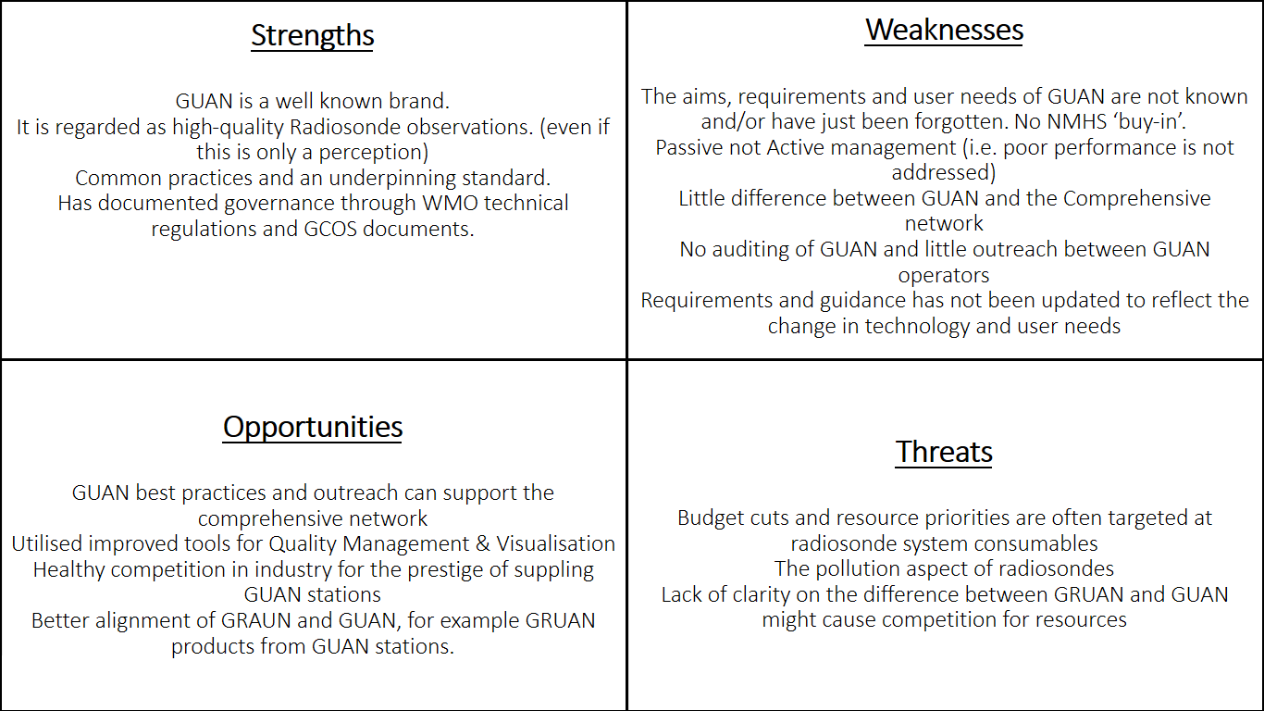

Annex 5: List of Participants

Peter Thorne (Ireland) peter.thorne@nuim.ie Maynooth University
Hiram Escabi (USA) hiram.escabi@noaa.gov NOAA
Bruce Ingleby (UK) bruce.ingleby@ecmwf.int ECMWF/Met Office
Marc Schroeder(Germany) Marc.Schroeder@dwd.de DWD
Richard Querel(New Zealand) Richard.Querel@niwa.co.nz NIWA

Ruud Dirksen(Germany) Ruud.Dirksen@dwd.de DWD/GRUAN (Local Host)
Michael Sommer(Germany) Michael.Sommer@dwd.de DWD/GRUAN (Local Host)
Christopher von Rohden(Germany) Christoph.Rohden-von@dwd.de DWD/GRUAN (Local Host)

GCOS Secretariat:
Caterina Tassone ctassone@wmo.int
Tim Oakley toakley@wmo.int
Valentin Aich vaich@wmo.int

