Task Team on the GCOS Upper Air Network (GUAN)
Background
AOPC-22 (Exeter, UK, March 2017) agreed on the creation of a dedicated task-team to deliver progress upon a number of actions in the GCOS Implementation Plan (GCOS 200) related to the operation and monitoring of the GCOS Upper Air Network:
• Reviewing the network requirements;
• Assessing and documenting the benefits of meeting stated requirements;
• How it contributes as a baseline network in the tiered network framework with GRUAN and the comprehensive network.

Membership

Chair (If no suitable candidate, agreed on a meeting by meeting basis)
AOPC Expert – Peter Thorne (peter.thorne@nuim.ie) – Maynooth University (Ireland)
GRUAN Expert – Richard Querel (Richard.Querel@niwa.co.nz) – NIWA (New Zealand)
NWP Expert – Bruce Ingleby (bruce.ingleby@ecmwf.int) – ECMWF (UK)
CBS/National Expert – Hiram Escabi (hiram.escabi@noaa.gov) – NWS (USA)
Satellite Expert – Marc Schroeder (Marc.Schroeder@dwd.de) – DWD (Germany)
National Expert – (Large GUAN contribution – China, Japan, Russia?)
GCOS Network Manager (Secretariat support) – Tim Oakley (toakley@wmo.int) (UK)
GCOS AOPC Scientific Office (Secretariat support) – Caterina Tassone (ctassone@wmo.int) (Switzerland)
CIMO expert team on upper air systems representative – Later meeting, if required
HMEI Observer – Later meeting, if required

Terms of Reference
(as approved by AOPC-22 and email xx/xx/2017)

Scientific charge
- Complete actions A13 and A14 in the GCOS IP on the GUAN vision, and start the implementation of any resulting changes to GUAN. As part of this process document the benefits of GUAN.
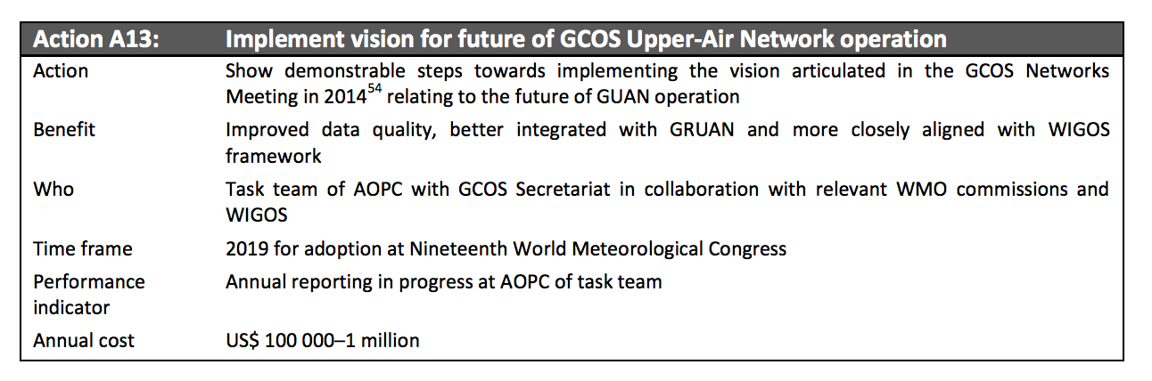
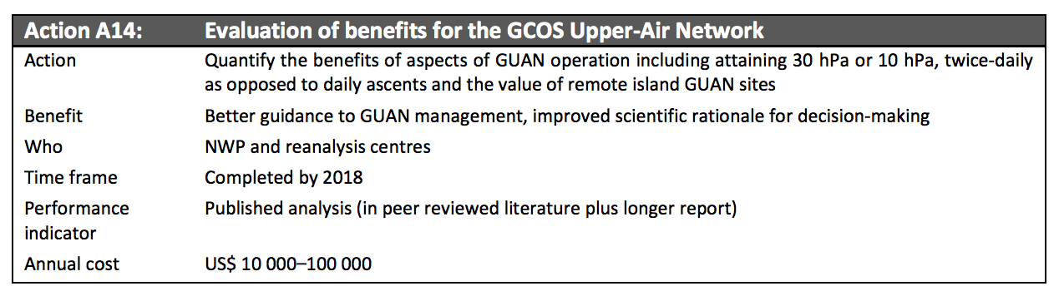
- Specifically, review and update the requirements of the GUAN, in terms of:
  - Availability
Currently the GUAN membership is primarily a result of location, historical records and a commitment by WMO Members. Management is primarily passive, informing and encouraging, which means that underperforming stations are rarely censured. The task team should consider whether an alternative metric or set of metrics should be used in future. This consideration should extend to timeliness and vertical resolution considerations.
b) Scheduling
GUAN radiosondes are currently launched at 00 and / or 12Z for historical reasons. The task team should assess from the range of climate application areas (trend detection, satellite cal / val, process understanding etc.) whether a change to this guidance is required. This should be done in collaboration with CBS Expert-Team in Surface Based Observations.
c) Balloon burst height
GUAN radosondes at many of the stations do not meet the stated heights required in GCOS-144. Analysis is required to assess the cost-benefit basis of making regular ascents to the height currently stipulated.
d) Required quality.
Should GUAN sites launch radiosondes that meet certain quality criteria? If so, how should these criteria be assigned and assessed to ensure a robust and fair system?

- Monitor the use of BUFR reporting and the associated metadata for GUAN GCOS IP A5
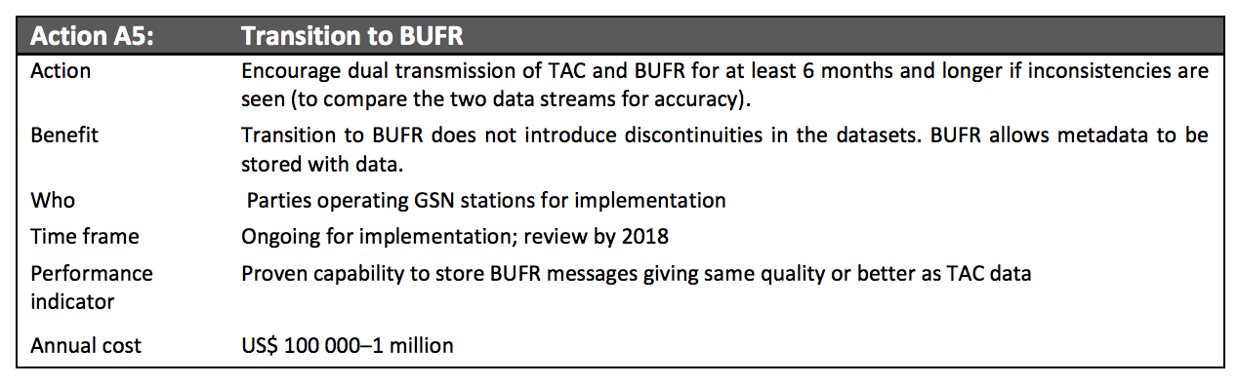
- Document requirements and propose a process for retaining original radiosonde measurements (raw data) as detailed in GCOS IP A17.
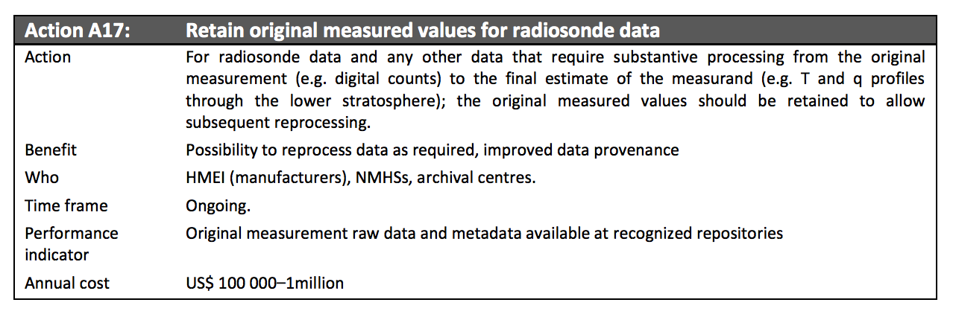

Modus operandi
- The task team shall exist for an initial period of two years.

- The task team shall work primarily remotely, facilitated by GCOS secretariat. It is expected that an initial ‘in person’ meeting will be organized to discuss and agree the work-plan and deliverables, further meetings will be decided as required.

- Within 3 months of the initiation of the task-team a detailed work plan and deliverable will be agreed.

- The task team chair shall be expected to report annually on progress to AOPC by means of a brief written report and, if support available, verbal reporting in person.

- The task team shall be expected to lead the production of a final report which may form the basis for any modifications recommended by AOPC to GUAN’s future operation.

Background documents
The Global Observing System for Climate: Implementation Needs, GCOS-200, https://library.wmo.int/opac/doc_num.php?explnum_id=3417

Status of the Global Observing System for Climate - Full Report, GCOS-195, http://www.wmo.int/pages/prog/gcos/Publications/GCOS-195_en.pdf

Workshop on the review of the GCOS Surface Network (GSN), GCOS Upper-Air Network (GUAN), and related atmospheric networks, Ispra, Italy, April 2014, GCOS-182, http://www.wmo.int/pages/prog/gcos/Publications/gcos-182.pdf

Guide to the GCOS Surface Network (GSN) and GCOS Upper-Air Network (GUAN) (2010 Update of GCOS-73), GCOS-144, http://www.wmo.int/pages/prog/gcos/Publications/GCOS-144_en.pdf

