

GCOS Strategy

Draft Version 2.0, April 27, 2018

**advocate - coordinate - communicate**

Document Planning

|  |  |  |  |
| --- | --- | --- | --- |
| Draft Versions |  |  |  |
| Version 1.8 | This version has been drafted by the GCOS Secretariat. |  | 19 February 2018 |
|  | Circulated to all GCOS Steering Committee members. | Deadline for comments | 1 March 2018 |
| Version 1.9 | This version will have comments from SC members included and will be circulated for comments to sponsors focal points: WMO (Johannes Cullmann; IOC Albert Fischer; ICSU: Katsia Paulavets; UNEP: Jian Liu) | Deadline for comments | 26 March 2018 |
| Version 2.0 | This version includes comments from all sponsors focal points. |  |  |

**Contents**

1. Purpose of this Document 7

2. Vision and Aims 7

3. New Challenges 11

3.1. Expanded range of users for climate observations 11

3.2. New Observation Technologies 12

3.3. Need for Urban Observations 12

4. Links with Sponsors 12

4.1. World Meteorological Organization (WMO) 13

4.2. Intergovernmental Oceanographic Commissions (IOC) 14

4.3. International Council for Science (previously ICSU) 14

4.4. UN Environment (UNEP) 14

5. Components 15

5.1. Define and Monitor Observational Needs 17

5.2. Support and Guide the Global Monitoring System 17

5.3. Open Data 18

5.4. Coordination 18

5.5. Communication 18

6. Governance 19

Annex A - Essential Climate Variables 21

Annex B - A Brief History of GCOS 23

Annex C - GCOS’ Mandate 25

**Information Boxes**

Box 1 GCOS Products 10

Box 2 Open Data 11

Box 3 WMO 13

Box 4 New Elements of this new GCOS Strategy 16

Box 5 Essential Climate Variables (ECV) 21

Box 6 Definitions 24

Box 7 The UN Framework Convention on Climate Change (UNFCCC, MAY, 1992) 25

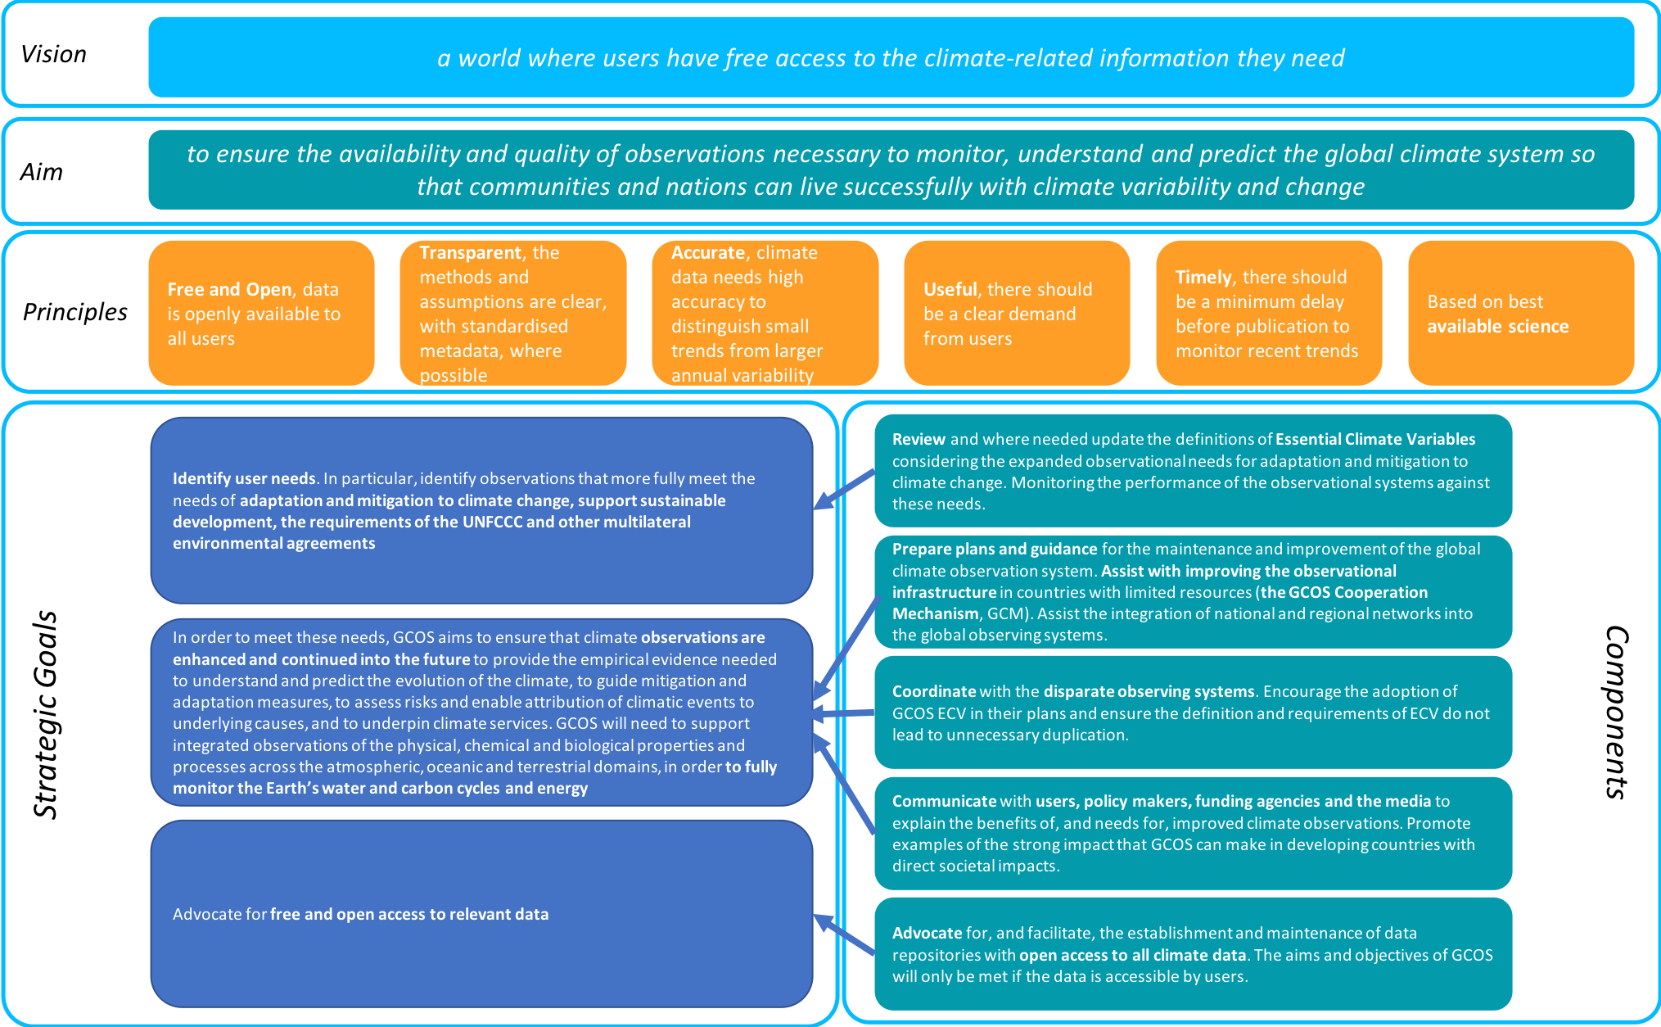

Figure 1 Summary of the GCOS Strategy

# Purpose of this Document

Following its establishment in 1992, a GCOS Plan[1] published in 1995 focussed on supporting understanding of climate and climate change. Since then, much has changed: the science has improved enormously, the UN Framework Convention on Climate Change (UNFCCC) reached its Paris Agreement on limiting climate change, the Sendai Framework for Disaster Risk Reduction was approved. The UN’s 2030 Agenda for Sustainable Development with its 17 goals frame many global policy agenda: SDG 13 unequivocally states the need to take urgent action to combat climate change and its impacts in the sustainable development context. Adaptation and mitigation to climate change and disaster early warning systems are vital.

The four priorities for action identified by the Sendai Framework include *Understanding disaster risk* and *Enhancing disaster preparedness* – both of which depend on observations to support long-term predictions and estimates of risk to support risk management.

New observing technologies have become available from satellites and automated ocean buoys to simple citizen science approaches.

This document presents a new strategy for GCOS to address the needs for climate observations in light of these recent developments. GCOS advocates and coordinates observing systems that support evidence-based policy making and risk management across a range of multilateral environmental agreements.

In 2016 GCOS, published its latest implementation plan which addresses some of these issues. As recommended in the GCOS review, “*GCOS should develop a short statement of strategy, based on the vision to guide priority setting and to communicate to stakeholders the aims and intended benefits of GCOS*”. This is that strategy document.

# Vision and Aims

Climate change is now affecting every country on every continent. It is disrupting national economies and affecting lives, costing people, communities and countries dearly today and even more tomorrow.

(Sustainable Development Goal, SDG 13).

Understanding, mitigating and adapting to climate change requires high quality climate data and information. The demands for climate data exceed what is currently available. They range from climate science to supporting climate policies, and cover the physical domains of atmosphere, oceans and land surface. Not all the required parameters are measured everywhere with sufficient accuracy, and even when observations are acquired, there are often spatial and temporal gaps. GCOS was founded in 1992 to help address these issues.

In addition to the UN Sustainable Development Goal 13 on climate action, climate observations are in particular also of immediate relevance to goals on clean water and sanitation, clean energy, cities and communities, responsible consumption and production, life below water and life on land (SDG Goals 6, 7, 11, 12, 14 and 15 respectively).

Users, especially in the policy sphere, often do not use observations directly but instead need to use information derived from observations such as statistical analyses, outputs of reanalysis and models. Services using such information depend on accurate and timely long-term observational data. GCOS’s role is to improve, support and ensure the availability of global climate observations: GCOS strives to ensure all users have access to climate observations, data records and information required to address their climate-related concerns.

|  |
| --- |
| **VISION**  ***a world where users have free access to the climate-related information they need*** |

To improve and support global climate observations, GCOS cooperates and coordinates with a range of existing observational systems and capacities. These include the WMO Integrated Global Observing System (WIGOS), the Global Ocean Observing System (GOOS), the Committee on Earth Observation Satellites (CEOS) and the Coordination Group for Meteorological Satellites (CGMS). It also plays a significant role for the broader observation requirements of the Global Framework for Climate Services (GFCS) and the World Climate Research Programme (WCRP) and the Group on Earth Observations (GEO).

GCOS collects and synthesizes the observational needs expressed by user communities and produces practical guidance on what should be the focus of observations of the climate system. GCOS supports all components of the World Climate Programme, the assessment role of the Intergovernmental Panel on Climate Change (IPCC), and the international policy role of the UNFCCC. It specifically encourages the provision of comprehensive and continuous climate and climate-related data and information to climate service providers.

GCOS is not, however, itself a research, application or service delivery system. Rather, it is intended to underpin and support the wide range of international programs and systems for climate research, applications and services and their counterpart activities at the national level in individual countries.

|  |
| --- |
| **AIM**  ***to ensure the availability and quality of observations necessary to monitor, understand, and predict the global climate system so that communities and nations can live successfully with climate variability and change*** |

In the future GCOS will have **three strategic goals**:

1. **Identify user needs**. In particular, identify observations that more fully meet the needs of **adaptation and mitigation to climate change, support sustainable development, the requirements of the UNFCCC and other multilateral environmental agreements (MEA)**
2. In order to meet these needs, GCOS aims to ensure that **climate observations are enhanced and continued** into the future to provide the empirical evidence needed to understand and predict the evolution of the climate, to guide mitigation and adaptation measures, to assess risks and enable attribution of climatic events to underlying causes, and to underpin climate services. GCOS will need to support integrated observations of the physical, chemical and biological properties and processes across the atmospheric, oceanic and terrestrial domains, in order to **fully monitor the Earth’s water and carbon cycles and energy**
3. Advocate for **free and open access** to relevant data

These goals include three new topics that will make GCOS more relevant to current and future societal needs. Improving monitoring of the Earth’s water and carbon cycles and energy balance will improve predictions and risk assessments. Extending the free and open access to data will support an improved and broadened range of climate services and is in accordance with WMO regulations and UNFCCC decisions. Finally, identifying needs across a broader range of environmental and sustainable development issues will allow observations supported by GCOS to be used to address many societal needs, assist countries meeting their requirements under the UNFCCC and other MEAs, and ensure consistency across the range of Earth observations.

GCOS will plan an observing system that is built, as far as possible, on the climate-related components of partner`s established observing systems (see Figure 2).

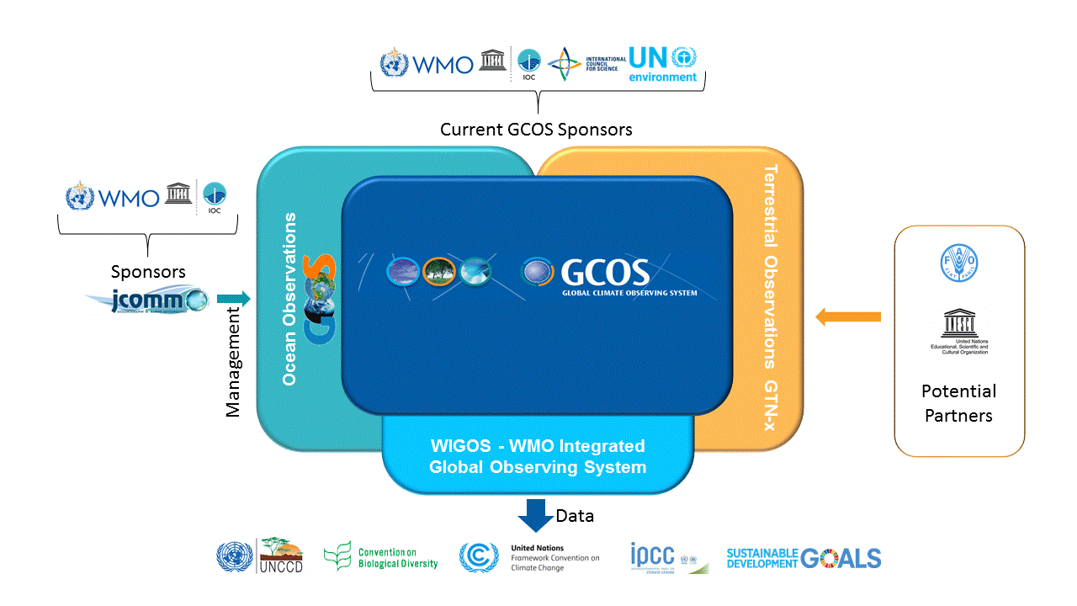

Figure 2 – Current relationship of GCOS with other observing systems: GCOS integrates the climate related parts of the existing domain-based observing systems: Global Ocean Observing System (GOOS) for the ocean; the WMO Integrated Global Observing System (WIGOS) for the atmosphere that itself integrates the Global Observing System (GOS); Global Atmosphere Watch (GAW), and the Global Cryosphere Watch (GCW), the WMO Hydrological Observing System (WHOS) and other terrestrial observations including Global Terrestrial Networks for x=: glaciers, permafrost, rivers; lakes, and hydrology, (GTN-x). GCOS has a relationship with FAO, by virtue of FAO’s former lead in terrestrial observations and relates to the WMO-IOC Joint Technical Commission for Oceanography and Marine Meteorology through its Observation Coordination Group (OCG). GCOS reports to the UNFCCC but also may serve other organisations. UNESCO has a special relationship for terrestrial observations through the International Hydrological Programme.

GCOS supports observational systems and networks that meet the following principles:

* **Free and Open:** data is openly available to all users (see Box 2)
* **Transparent**: the methods and assumptions are clear, with standardised metadata, where possible
* **Highly accurate: climate data** needs high accuracy to distinguish small trends from larger annual variability
* **Useful**: there should be a clear demand from users.
* **Timely**: there should be a minimum delay before publication to monitor recent trends
* Based on **best available science**

|  |
| --- |
| Box 1 GCOS Products  GCOS products include:   * **Essential Climate Variables (ECV)** definitions and observational requirements (see Annex A) * Definitions of Climate Indicators * **Climate Monitoring Principles** approved by the UNFCCC (decision 11/CP.13) and adopted by Resolution 9, WMO Congress (Cg-XIV) * GCOS Monitoring Guidelines, (GCOS-143) * **Implementation Plans.** The latest is “The Global Observing System for Climate: Implementation Needs”, (GCOS-200) (2016) * **Status Reports.** The latest is “Status of the Global Observing System for Climate”, (GCOS-195) (2015)   **GCOS ECV Requirements**  An important product produced by GCOS are the ECV requirements. It is not sufficient to simply identify the ECV that should be measured but GCOS also identifies the parameters to be measured for each ECV, called ECV products (e.g. to specify the ocean inorganic carbon both the interior ocean carbon storage and the pCO2 are needed). For each of these ECV products the accuracy, resolution and long-term stability required by users have been specified.  It is now apparent that this will not be sufficient into the future. Climate observations will not just be used to improve climate science but also to guide mitigation and adaptation measures, to assess risks and enable attribution of climatic events to underlying causes, and to underpin climate services.  GCOS will include these new user requirements by modifying the current approach: a range of accuracy and resolutions will be provided where the highest accuracy and resolution meets all these needs and the lower accuracy and resolution provides some benefits but not all. It may also be necessary to provide specific requirements for specific applications. Some ECV may need to be measured at different scales in different regions (e.g. the open ocean versus coastal waters, the tropics versus temperate regions). Future ECV product requirements will need to accommodate these differences.  The science panels will work towards revising and updating the ECV product requirements as part of their contribution to updating the GCOS implementation plans. |

|  |
| --- |
| Box 2 Open Data  Open data is data that can be freely used, re-used and redistributed by anyone - subject only, at most, to the requirement to attribute and share-alike[2].  The full Open Definition (see <http://opendatahandbook.org>) gives precise details as to what this means. To most important are:   * Availability and Access: the data must be available as a whole and at no more than a reasonable reproduction cost, preferably by downloading over the internet. The data must also be available in a convenient and modifiable form. * Re-use and Redistribution: the data must be provided under terms that permit re-use and redistribution including the intermixing with other datasets. * Universal Participation: everyone must be able to use, re-use and redistribute - there should be no discrimination against fields of endeavour or against persons or groups. For example, ‘non-commercial’ restrictions that would prevent ‘commercial’ use, or restrictions of use for certain purposes (e.g. only in education), are not allowed.   Open climate data has been mandated by the UNFCCC and WMO. This is important to support the most vulnerable to climate change (often the most disadvantaged) in their adaptation. Open access also is important for interoperability: Interoperability is the ability of diverse systems and organizations to work together with different datasets.  The International Council for Science also advocates for open access to peer-reviewed research publications, the data on which the results and conclusions of this research are based, and any software or code used in the course of the research[3]. |

# New Challenges

GCOS was established in 1992 (see Annex B). However, it is now facing new challenges. With the UNFCCC Paris Agreement[4] of 2015, there is a wide consensus that supporting climate policy to address adaptation and mitigation is vital. The science has improved dramatically: the existence of anthropogenic climate change is clear and warming of the climate system is unequivocal[5].

This consensus on the need to act to mitigate and adapt to climate change together with improving and expanding observational technologies leads to more demands on the global climate observing system.

## Expanded range of users for climate observations

GCOS will consider how best to support users beyond its traditional role of supporting the science and understanding of climate change to include the global climate related observation needs of **adaptation, mitigation, sustainable development, disasters and emergency response, and in responding overall to the Paris Agreement**. This will include identifying additional ECVs and developing their definitions and observational requirements, as has been done for the existing ECVs, or include these needs in existing ECVs. In addition, GCOS will identify actions that need to be implemented by the observing systems to address these additional needs. These broader demands on the observing system will require GCOS involving a wider **range of users and experts** and will extend the relevance of GCOS in wider policy, economic and social communities.

In order for climate observations to support an improved understanding of the climate system, a better attribution of events, and more reliable forecasts and projections, GCOS will need to ask for the whole climate system to be monitored. GCOS will incorporate **the Earth’s water and carbon cycles and energy balance** in their entirety and aim to explain the changing conditions of the biosphere. GCOS now has targets for closing these cycles and will monitor how well, as a whole, they are consistently observed. The individual ECV requirements will be revised to be consistent with these goals.

## New Observation Technologies

**Observation technology is evolving**. An example has been in the oceans with new autonomous equipment collecting data. New and higher resolution satellite data is becoming available. Other developments that use lower levels of technology but are likely to grow must be considered by GCOS. Crowd sourced data and inexpensive equipment that can be deployed in large numbers (such as CoCoRaHS[6] plastic rain gauges) may provide cost-effective solutions, especially to address some of the new challenges such as emergency response and adaptation. The quantity of this data can lead to challenges for users accessing and using this data, epically where internet capacity is limited. GCOS will need to consider these new technologies and how they can contribute in the future. Assessing this data and ensuring access to it for all will be important parts of future plans.

## Need for Urban Observations

A clear trend over the past decades has been a migration of individuals into cities, with over 50% of the world’s population now living in urban areas. Traditionally much monitoring has taken place outside large conurbations to avoid local conditions influencing observations. However, observations are needed where people live, especially in **the new urban megacities**, to support adaptation, sustainable development and disasters as well as emergency response and resilience. GCOS will develop plans to address this.

Finally, to ensure high quality data is available, GCOS will need to **improve its monitoring of the performance of ECV observations** and implementation of the GCOS plans. This should be a central part of the work of the Science Panels.

# Links with Sponsors

The programme meets many needs for the major sponsors[7]:

* **For WMO**: GCOS supports the work of WMO in climate-related matters throughout the UN system. GCOS is an essential element of GFCS. GCOS gives technical guidance to the National Meteorological and Hydrological Services (NMHSs) on climate observations. And GCOS is building the platform to coordinate with partner programmes, supporting WIGOS activities in the area of climate and serving the sustained observational needs of WCRP.
* **For IOC**: GCOS provides IOC with guidance and the coordination mechanism for the climate-element of the Global Ocean Observing System (GOOS). GCOS is the overarching mechanism for Joint Technical Commission for Oceanography and Marine Meteorology (JCOMM) activities, setting the requirements.
* **For UNEP**: GCOS provides the observational backbone of UNEP regional and sector focused activities, in particular for vulnerability and impact studies.
* **For ICSU**: GCOS provides the scientific community with climate observations requirements and with access to climate information, and it provides access to climate observations from research networks. GCOS shares with ICSU the goal of free data sharing and access of information.

## World Meteorological Organization (WMO)

WMO and National Meteorological and Hydrological Services (NMHS) have a central role in many climate observations, especially in the atmosphere and oceans (see Box 3). Observations by NMHS were originally established to meet the needs of weather forecasting; climate requires different levels of accuracy and stability, longer time series and different temporal and spatial resolutions. Climate is **NOT** just average weather: the climate system encompasses the Earth’s carbon and water cycles and the energy balance. This goes beyond the traditional remit of NMHS and may involve other organisations; for example, biomass stocks, ocean acidity, the terrestrial biosphere and ecosystems and sea level are all extremely important climate variables.

WMO and GCOS’ main priority for the Earth observation programmes is to respond to the potential impacts on human lives, livelihoods and infrastructure. The Paris Agreement covers a very wide range of topics: adaptation, mitigation, disaster risk reduction, loss and damage, transparent reporting and a global stocktake to assess progress and increase ambition of emission reductions. Thus, NMHS are facing new challenges driven by the need to support policy makers’ planning for climate change adaptation and mitigation. However, responding to climate change and supporting national policy makers opens NMHS to new funding opportunities and the chance to serve new customers. Using the existing observations systems, with the additional climate needs addressed, increases the value and utility of the observations supported by NMHS.

|  |
| --- |
| Box 3 WMO  Atmospheric observations made by NMHS are coordinated through WMO. WMO also coordinates, and integrates through WIGOS[8], observations of atmospheric composition (GAW[9]), hydrology (WHYCOS[10] and WHOS[11]) and the cryosphere (GCW[12]). Together with the IOC of UNESCO, it coordinates the Global Ocean Observing System (GOOS[13]) through JCOMM[14] (See Figure 1) GCOS works with all these programmes.  The ECV requirements produced by GCOS will be input into the WMO systems[15].  The GCOS strategy complements WMO priorities and strategic goals as follows:   * GCOS’ increased focus on the observations underpinning ***adaptation and mitigation, disaster risk reduction and other climate services*** will ensure global climate observations ***better serve societal needs*** * GCOS’ aim is to ***enhance climate-related Earth system observations*** * GCOS will improve the monitoring of the Earth’s carbon and water cycles and energy balance, which will ***advance scientific knowledge of the Earth system*** and ***improve NHMS’ predictive capabilities*** * GCOS has an ***active capacity building programme*** * GCOS strongly advocates for ***free and open access to all climate data*** |

GCOS provides direct capacity development support to NMHS through the GCOS Cooperation Mechanism. GCOS will continue to support international cooperation, interaction and exchange allowing consistent, comparable and transparent monitoring of these variables and open access to the data by NMHS and other users. Plans for improvements to operational observation systems for climate across multiple NMHS will be developed.

GCOS advocates for the free and open access to all climate data, in accordance with WMO resolutions and the UNFCCC decisions, including processed data such as modelling and reanalysis, which will increase the data resources available to NMHS at little or no cost.

Members of WMO are Parties to the UNFCCC. Therefore, the requirements for systematic observations and, under the Paris Agreement, the transparency framework for observations and reporting apply to members of the WMO. The development of climate indicators by GCOS and the open availability of ECV datasets will assist members of the WMO in meeting these obligations under the Agreement.

## Intergovernmental Oceanographic Commissions (IOC)

The Intergovernmental Oceanographic Commission, established in 1960 as a body with functional autonomy within UNESCO, is the only competent organization for marine science within the UN system. Together with the other GCOS sponsors, the IOC also sponsors the Global Ocean Observing System (GOOS). The WMO-IOC Joint Technical Commission for Oceanography and Marine Meteorology (JCOMM) responds to interdisciplinary requirements for meteorological and ocean observations, data management and service products.

## International Council for Science (previously ICSU)

The International Council for Science advocates for open access to peer-reviewed research publications, the data on which the results and conclusions of this research are based, and any software or code used in the course of the research[16].

## UN Environment (UNEP)

The United Nations Environment Programme (UN Environment) is the leading global environmental authority that sets the global environmental agenda, promotes the coherent implementation of the environmental dimension of sustainable development within the United Nations system. UNEP GRID centres not only facilitate access to but directly provide environmental data and information for decision-making and policy setting; underpin UN Environment's ongoing review of environmental state and trends; and provide early warnings about emerging environmental problems and threats.

# Components

The GCOS strategy has the following components (see Figure 1) that are discussed in more detail in sections ‎5.1 to ‎5.5:

1. Review and where needed update the definitions of Essential Climate Variables (ECV, see Box 1 and Annex A) considering the expanded observational needs for adaptation and mitigation to climate change. Monitoring the performance of the observational systems against these needs (Goal 1).
2. Prepare plans and guidance for the maintenance and improvement of the global climate observation system. Assist with improving the observational infrastructure in countries with limited resources (the GCOS Cooperation Mechanism, GCM). Assist the integration of national and regional networks into the global observing systems (Goal 2).
3. Advocate for, and facilitate, the establishment and maintenance of data repositories with open access to all climate data. The aims and objectives of GCOS will only be met if the data is accessible by users (Goal 3).
4. Coordinate with the disparate observing systems. Encourage the adoption of GCOS ECV in their plans and ensure the definition and requirements of ECV do not lead to unnecessary duplication. (Goal 2)
5. Communicate with users, policy makers, funding agencies and the media to explain the benefits of, and needs for, improved climate observations. Promote examples of the strong impact that GCOS can make in developing countries with direct societal impacts (Goal 2).

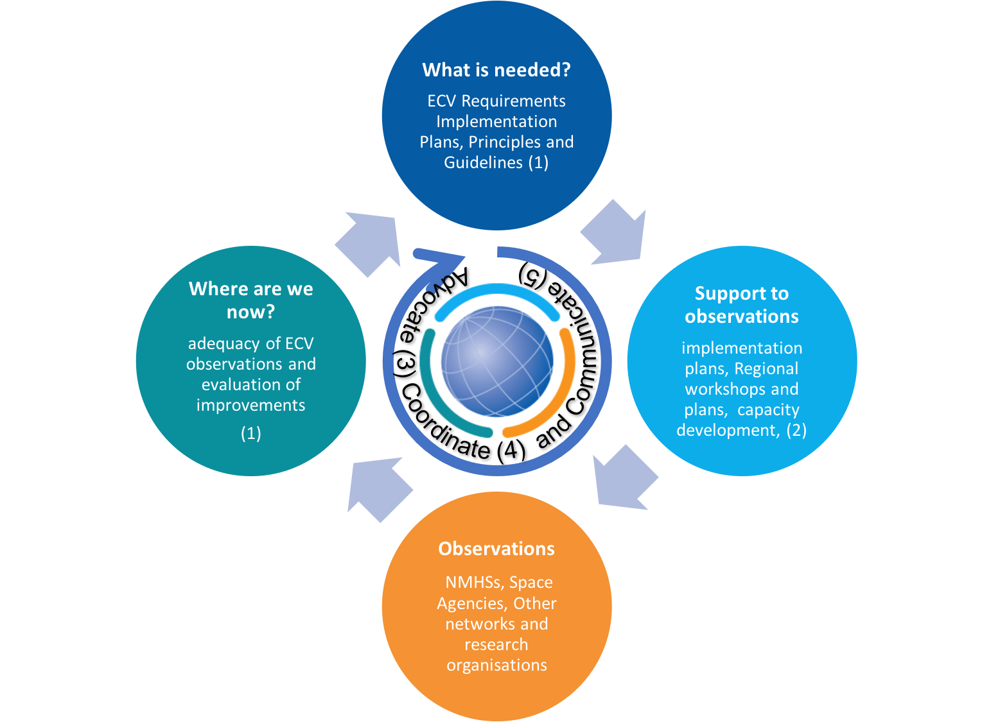

Figure 3 – GCOS Components (numbers refer to components above)

GCOS operates through a cycle (Figure ) of specifying needs 🠲 providing support 🠲 observations (performed by independent systems and networks) 🠲 monitoring performance of observations and back to specifying needs. In the past, this sequence has been unfolding on a roughly 10-year cycle (with an update mid-way).

From now on, GCOS will aim to synchronise this cycle on the dates of the Paris Agreement’s Global Stocktake,

|  |
| --- |
| Box 4 New Elements of this new GCOS Strategy  This strategy has and broader understanding of users of climate data and their needs. These new needs will be addressed by broadening the focus of GCOS rather than specific new actions. These new topics are highlighted here.   * Promote and support the observations needed to guide mitigation and adaptation measures, to assess risks and enable attribution of climatic events to underlying causes, and to underpin climate services. * Aim to holistically observe the Earth’s carbon and water cycles and energy budget as well as monitoring change in the biosphere. This will lead to improvements in our ability to predict climate as well as estimate future risks. * Develop an approach to urban monitoring to improve the understanding of change in the urban environment. This is where most people now live and where climate impacts will be experienced. * Increase the dialogue with users, providing more opportunities for users to articulate their needs and to contribute and comment on GCOS products (Box 1). * Advocate for free and open access to climate data, in accordance with WMO and UNFCCC regulations and decisions: data must be available to a wide range of users to maximise its benefits * Coordinates the definition of climate indicators for policy makers and informing the broader public on the scale and rate of change of climate. |

the first of which is in 2023. New elements of the new GCOS strategy are listed in Box 4.

## Define and Monitor Observational Needs

GCOS will review and update the list of ECVs and their requirements, considering the outcome of public reviews and the needs of users in appropriate application areas. Applications include science (the traditional GCOS customers, e.g., climate research, attribution of weather and climate events, operational climate prediction, impacts and vulnerability assessments), and climate policy (new areas that GCOS must address to remain relevant, e.g., adaptation, mitigation, sustainable development, disasters and emergency response, resilience, and supporting the Paris Agreement).

New elements include:

* Ensuring a greater input with the observation communities through more collaboration on specifying needs and open reviews.
* Consideration of the needs of the adaption, mitigation and the disaster risk reduction communities
* In the future[17], GCOS will aim to improve monitoring of the Earth’s carbon and water cycles and energy budget as well as changes in the biosphere to improve predictability and risk assessments. The objectives for these three cycles will be to meet targets for closing these cycles that will be published regularly in GCOS Implementation Plans. Requirements for observations across the cycles will need to be internally consistent.
* Develop an approach to urban monitoring to improve the understanding of change and human responses in the urban environment. This is where most people now live and where climate impacts will be experienced.

## Support and Guide the Global Monitoring System

GCOS will identify gaps and deficiencies (in the past published in “status” and earlier “adequacy” reports) and prepare and advocate for plans to remedy these problems in future observational frameworks (requested by the UNFCCC as “implementation plans” etc.). GCOS has also published climate monitoring principles (adopted by the UNFCCC[18]) and monitoring guidelines. When followed, the GCOS climate monitoring principles and guidelines, will ensure observations are of a sufficient quality for use for climate purposes. GCOS will encourage the use of the best cost-effective technologies and so will review new approaches and methods as they become available.

GCOS supports some networks directly (e.g. GRUAN, GUAN, and GSN) and should continue to do so. Other networks could be considered if appropriate to fill gaps.

GCOS will also facilitate with partners regional observing through regional workshops, plans etc. and through the GCOS Cooperation Mechanism. In addition, GCOS will consider how the global system can assist adaptation including through reanalysis and downscaling of models.

GCOS will undertake other activities as agreed by the Steering Committee that will lead to improvements in global observations.

## Open Data

Free and open data is a new priority component identified in this strategy. GCOS will facilitate free and open access to climate data through, inter alia:

* Identifying and encouraging data centres to make data globally available
* Encouraging use of DOI (Digital Object Identifier) and standardised metadata to enhance the “discoverability” of data worldwide
* Encouraging correct citation of data and crediting of data producers
* Support stakeholders in supplying data (ECV Inventory, Copernicus, etc.)
* Ensuring the long-term (indefinite) accessibility of data and supporting data rescue

In carrying out the above GCOS will work closely with the original observing agencies and data owners, to be consistent with international frameworks and practices for data exchange, such as the WMO Global Data-processing and Forecasting Systems (GDPFS).

## Coordination

GCOS will coordinate with the disparate observing systems and encourage the adoption of GCOS ECV in their plans while ensuring the definition and requirements of ECV do not lead to unnecessary duplication.

GCOS will use the monitoring performed by other observing systems, such as WIGOS, GAW, GCW, WHYCOS, GOOS etc. in its assessments. GCOS will explore synergies with observing needs for non-climate environmental issues and will consider extending the definitions of ECV to accommodate their requirements.

GCOS will collaborate with relevant stakeholders such as UNFCCC, WMO, IOC of UNESCO, ICSU, UNEP, other multilateral environmental agreements (MEA), IPCC and the Group on Earth Observations, GEO.

GCOS’ collaboration with space agencies through their coordinating bodies CGMS and CEOS has underpinned the observations of many ECV. Space agencies future plans take into account GCOS recommendations. GCOS will continue and strengthen this collaboration.

## Communication

GCOS will prepare a separate communication plan that will cover:

* listening to users’ needs and define ECV and their requirements in considering current or near future practical capabilities.
* reviewing the current global climate observation system and make proposals for its evolution to meet new and expanding needs
* advocating for improved observations and open access to the data
* promoting transparent access to climate indicators to improve public understanding and acceptance of climate change
* supporting the capacity building related to observational capabilities in countries with limited resources
* explaining the importance and benefits of climate observation, including the use of climate data in provision of climate services for improved social and economic benefit
* fundraising

GCOS has always worked with the relevant observational and user communities. However, in the future, given the broader range of users and needs, GCOS will need to put a larger emphasis on communicating with all these groups, in particular, by involving them in drafting requirements and plans and through open reviews and calls for suggestions.

# Governance

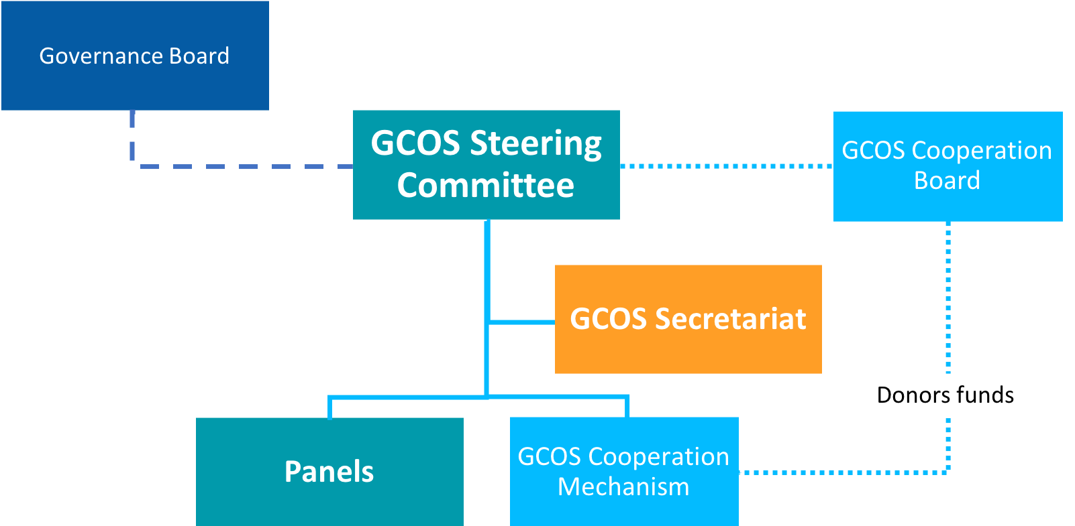

Figure 1 - Governance of GCOS

GCOS consists of (see Figure 1):

1. **Governance Board[19].** High-level input of GCOS sponsors into Steering Committee. This provides an opportunity for the sponsors to review progress and provide high-level guidance.
2. **The GCOS Steering Committee.** This is a group of scientific and technical experts appointed jointly by the GCOS sponsoring organisations to
   1. agree the annual work plan GCOS advise on its further development
   2. agree on scientific and technical matters and, in particular, on proposed ECVs, their requirements and implementation plans
   3. review the components of GCOS and report to the sponsors
3. **The GCOS Panels[20].** These are groups of experts whose task is to provide scientific and technical input into the GCOS **p**rogramme on, inter alia, climate monitoring needs, observational capacities and ECV specifications. They maintain an overview of the current status of the observational systems.
4. **The GCOS Cooperation Mechanism** resulted from deliberations at the 17th session of the UNFCCC Subsidiary Body for Scientific and Technological Advice (New Delhi, 2002), and was formalized in a decision of the 9th session of the Conference of the Parties to UNFCCC, COP9. It uses donor funds to make practical improvements to the observational capacities of countries with insufficient resources. It comprises the **GCOS Cooperation Board** as the primary means to facilitate cooperation among donor countries, recipient countries and existing funding and implementation mechanisms in addressing high-priority needs for improving climate observing systems in developing countries; and **the GCOS Cooperation Fund** as a means to aggregate commitments and voluntary contributions from multiple donors (both in kind and financial) into a common trust fund.
5. **The GCOS Secretariat.** The secretariat, led by the GCOS director, and staffed with senior science officers, is hosted at the WMO headquarters
6. Essential Climate Variables

|  |
| --- |
| Box 5 Essential Climate Variables (ECV)  The concept of Essential Climate Variables (ECV) emerged in the context of the needs of the UNFCCC in the Second Adequacy Report[21].  Data needs are organized around the concept of Essential Climate Variables (ECVs).  An Essential Climate Variable (ECV) is a physical, chemical or biological variable or group of linked variables that critically contributes to the characterization of Earth’s climate and human response. ECV datasets provide the empirical evidence needed to understand and predict the evolution of the climate, to guide mitigation and adaptation measures, to assess risks and enable attribution of climatic events to underlying causes, and to underpin climate services. The ECVs must not be understood as a select group of stand-alone variables; they are part of a wider concept (Figure *2*).  ECVs are identified according to the following criteria:   1. **Relevance:** The variable is critical for characterizing the climate system and its changes; 2. **Feasibility:** Observing or deriving the variable on a global scale is technically feasible, using proven, scientifically understood methods;   Figure 2 - Schematic of the ECV concept (Source: Bojinski, et al, BAMS, 2014).   1. **Cost-effectiveness:** Generating and archiving data on the variable is affordable, mainly relying on coordinated observing systems using proven technology, taking advantage where possible of historical datasets.   Knowing existing climate-relevant observing capabilities, climate datasets, and the level of scientific understanding of the climate system are the foundations (lower left box) necessary for selecting the ECVs from a pool of climate system variables. In addition, guidance is needed to make practical use of the ECVs (lower right box): user requirements capture the data quality needs of science, services and policy; climate-specific principles guide the operation of observing systems and infrastructure; guidelines facilitate the transparent generation of ECV data records. The latter address the availability of metadata, provisions for data curation and distribution, and the need for quality assessment and peer review. |

SOURCE: The Global Observing System for Climate: Implementation Needs, GCOS-200, 2016. Based on Bojinski, et al, (BAMS, 2014). DOI:10.1175/BAMS-D-13-00047.1

1. A Brief History of GCOS[22]

Systematic international coordination of weather and climate observations began in the mid 1800s and advanced rapidly in the 1960s and 1970s as the advent of digital computers and Earth-observing satellites inspired the establishment of the operational World Weather Watch and the Global Atmospheric Research Programme. The design of the WMO World Weather Watch (WWW) and the WMO-ICSU Global Atmospheric Research Programme (GARP) in the 1960s and 1970s had envisaged an operational and research observing system that would meet the need for observations for ‘climate’ as well as for ‘weather’ purposes.

The really great step forward came in the 1980s with the realisation that understanding and prediction of climate would require the involvement of a much wider set of scientific communities and comprehensive observation of the entire atmosphere-ocean-land-biosphere climate system. This inspired the vision for an integrated Global Climate Observing System (GCOS).

It became clear, however, during the 1980s that the emerging challenges of human-induced climate change would require a more climate-focussed and better integrated observing system than could be solely provided by the WWW Global Observing System (GOS) for traditional atmospheric climate variables and the WMO Global Atmosphere Watch (GAW) for atmospheric chemistry. The early years of the World Climate Research Programme (WCRP) provided compelling evidence of the need for an integrated cross-domain (atmosphere-ocean-land) observing system as a basis for monitoring, understanding, and eventually predicting, both the natural variability of, and the human influence on, the global climate system. In the final chapter (‘Narrowing the uncertainties’) of the IPCC Working Group I (climate science) component of the IPCC’s First Assessment Report, the Chairs of the Joint Scientific Committee for the WCRP and the Scientific Committee for the International Geosphere-Biosphere Programme (IGBP) called for development of a comprehensive Global Earth Observing System and, in particular, for improvement of the global atmosphere and land surfaces observing system; and development of a global ocean and ice observing system.

IPCC First Assessment Report 1990 concluded: *that improved predictability of (human induced) climate change would require improved systematic observation of climate related variables on a global basis*.

The 1990 Second World Climate Conference undertook a comprehensive review of the IPCC findings. The need for a greatly improved global observing system for climate featured strongly in both formal and informal discussions at the Conference. The Conference Statement concluded, inter alia, that *Present observational systems for monitoring the climate system are inadequate for operational and research purposes. They are deteriorating in both industrialised and developing regions*. It went on to assert that *There is an urgent need to create a Global Climate Observing System (GCOS) built upon the World Weather Watch Global Observing System and the Integrated Global Ocean Service System and including both space-based and surface-based observing components…* The Statement then elaborated the needs to be met through the proposed system and concluded that *The further development and implementation of the GCOS concept should be pursued, with urgency, by scientists, governments and international organisations*.

One of major outcomes of the Second World Climate Conference (SWCC) in 1990 was the invitation of the World Meteorological Congress to strengthen monitoring and research within the World Climate Programme. Following this invitation, an expert meeting hosted by the UK Meteorological Office in Winchester, United Kingdom in January 1991 elaborated the concept and sponsorship arrangements for a Global Climate Observing System.

The Winchester proposal was immediately submitted for approval by the 1991 sessions of the governing bodies of the proposed GCOS sponsors, i.e.

* the World Meteorological Organization (WMO);
* the Intergovernmental Oceanographic Commission (IOC) of UNESCO;
* the United Nations Environment Programme (UNEP, now UN Environment) and;
* the International Council for Science (ICSU).

The essential charter of GCOS, including the governance and financial arrangements for its implementation, were incorporated in an inter-agency Memorandum of Understanding (MoU). The MoU established a Joint Planning Office (later renamed the GCOS Secretariat) at WMO Headquarters in Geneva, a Joint Scientific and Technical Committee (which eventually became the GCOS Steering Committee) was appointed, and, by mid-1995, a comprehensive GCOS Plan had been finalized. The commitments of WMO, IOC of UNESCO, UN Environment and ICSU are documented in Annex C *GCOS Mandate*.

|  |
| --- |
| Box 6 Definitions  It is often important to distinguish between the Global Climate Observing System (GCOS) which is the programme described here and the global climate observing system, which refers to the broader combination of all the relevant observing systems and GCOS itself. |

1. GCOS’ Mandate

GCOS and the UNFCCC are both formally products of WMO`s Second World Climate Conference. In response to the First Assessment Report of the IPCC, Articles 4 and 5 of the UN Framework Convention on Climate Change included specific national obligations in respect of ‘research and systematic observation’.

|  |
| --- |
| Box 7 The UN Framework Convention on Climate Change (UNFCCC, MAY, 1992)  ***Article 4.1 (g) Commitments***  All Parties shall: 1(g) Promote and cooperate in scientific, technological, technical, socio-economic and other research, **systematic observation** and development of data archives related to the climate system……….  ***Article 5 Research and Systematic Observations***  … the Parties shall: (a) Support and further develop…programs and networks or organizations aimed at defining, conducting, assessing and financing research, data collection and systematic observation, taking into account the need to minimize duplication of effort; (b) Support international and intergovernmental efforts to strengthen systematic observation …. particularly in developing countries, and to promote access to, and the exchange of, data and analyses thereof…… |

WMO, IOC of UNESCO, UNEP and ICSU responded by creating the Global Climate Observing System, GCOS in 1992. All sponsoring organizations have anchored their commitments to GCOS in the following resolutions and decisions of their Executive Bodies:

1. Resolution 15 (Cg-17) of the Seventeenth World Meteorological Congress on the World Climate Programme (WCP);
2. Resolution 39 (Cg-17) of the Seventeenth World Meteorological Congress on the Global Climate Observing System (GCOS);
3. Resolution 48 (Cg-XVI) of the Sixteenth World Meteorological Congress on the implementation of the Global Framework for Climate Services (GFCS);
4. The decision of the sixtieth meeting of the ICSU Executive Board that ICSU should join WMO and IOC of UNESCO in the formation of the Global Climate Observing System;
5. The decision of the sixteenth session of the UNEP Governing Council that UNEP should support, within available resources, the creation of a Global Climate Observing System and assist in ensuring that its development and implementation are pursued with urgency;
6. Resolution 50 (Cg-XVI) of the Sixteenth World Meteorological Congress on the implementation of the WMO Integrated Global Observing System (WIGOS);
7. Resolution XVI-8 of the sixteenth session of the IOC Assembly to undertake the development of a Global Ocean Observing System (GOOS) and participate in the Global Climate Observing System.

Through the work of its sponsors and their individual and co-sponsored observing systems, GCOS has become a vital source of observational support for climate change research and assessment, a highly valued advisory mechanism for climate change negotiations, a successful prototype for other frameworks, and the pre-eminent example of the UN System already ‘delivering as one on climate knowledge’.

1. GCOS (1995) Plan for the Global Climate Observing System (GCOS), Version 1.0, GCOS-14, WMO/TD - No 681
2. Share-alike is a copyright licensing term, originally used by the Creative Commons project, to describe works or licences that require copies or adaptations of the work to be released under the same or similar licence as the original.
3. See “*Open access to scientific data and literature and the assessment of research by metrics*”, ICSU Nov 2014.
4. UNFCCC Decision 1/CP.21, Paris Agreement: <http://unfccc.int/resource/docs/2015/cop21/eng/10a01.pdf>
5. See IPCC (2014) Climate Change 2014 Synthesis Report, IPCC Geneva
6. Community Collaborative Rain, Hail and Snow Network, <https://www.cocorahs.org/>
7. GCOS *Programme Review, Synthesis Report*, March 2014 GCOS-181
8. WIGOS: WMO Integrated Global Observing System
9. GAW: Global Atmosphere Watch: <http://www.wmo.int/pages/prog/arep/gaw/gaw_home_en.html>
10. WHYCOS: World Hydrological Cycle Observing System: <http://www.whycos.org/whycos/>
11. WHOS: WMO Hydrological Observing System, <http://www.wmo.int/pages/prog/hwrp/chy/whos/index.php>
12. GCW: Global Cryosphere Watch: <https://globalcryospherewatch.org/>
13. GOOS: <http://www.goosocean.org/>
14. JCOMM: WMO-IOC Joint Technical Commission for Oceanography and Marine Meteorology: <http://www.jcomm.info/>
15. Observing Systems Capability Analysis and Review Tool (OSCAR) (see <https://www.wmo-sat.info/oscar/>) and the Rolling Review of Requirements (RRR see <http://www.wmo.int/pages/prog/www/OSY/GOS-RRR.html>)
16. See “*Open access to scientific data and literature and the assessment of research by metrics*”, ICSU Nov 2014.
17. In the past GCOS has set requirements for individual ECV without consideration of how they fit together. In the future, there will be targets for how well entire climate cycles are observed.
18. Contained in the UNFCCC Revised Reporting Guidelines agreed in December 2007, decision 11/CP.13
19. Currently the Sponsors of GCOS are: WMO (who host and support the secretariat), IOC of UNESCO, ICSU (which will merge with ISSC to become International Science Council (ISC) in 2018) and UN Environment.
20. Currently (Jan 2018) there are three panels: the Atmospheric Observation Panel for Climate (AOPC); the Ocean Observations Panel for Climate (OOPC); and the Terrestrial Observation Panel for Climate (TOPC).
21. Second report on the adequacy of the global observing systems for climate in support of the UNFCCC. GCOS-82, 85 pp. [Available online at WMO Library [here](https://library.wmo.int/opac/doc_num.php?explnum_id=3931).]
22. Based on an article published in Weather in 2012 by all former Chairpersons of the GCOS Steering Committee. It has been shortened where it deemed appropriate: The GCOS at 20 years. The origin, achievement and future development of the Global Climate Observing System, Houghton, J.H.; Townshend, J; Dawson, K; Mason, P.; Zillman, J; Simmons, A., Weather, September 2012, Vol, 67, No.9, pp. 227-235, DOI: 10.1002/wea.1964.