GCOS Workshop:
Use of Space-based Essential Climate Variable (ECV) Observations for Climate Adaptation

Date: 6-7 February 2019

Venue: WMO, Geneva, Switzerland

Expected outcome:

Establishment of an ongoing, systematic dialogue between space agencies, those processing the data into products and users, aimed at optimizing the use and usefulness of related Climate Data Records (CDR) and other climate data.

Specific Goals:

Following the requirements established by the Global Climate Observing System (GCOS), satellite agencies are monitoring a wide range of ECVs. Worldwide, a range of satellite-based climate data records and processed data such as reanalysis and model outputs is now available. It is now time to assess how these data are used to support adaptation and related mitigation such as land use and to identify the major issues limiting the usefulness of the data. This workshop will initiate a user-provider dialogue to undertake this assessment, which will ultimately lead to better and more useful ECV data records.

The workshop brings together experts from relevant communities: the satellite data providers, reanalysis experts, climate and climate impact modellers, representatives from the WMO Regional Climate Centres (RCC) and adaptation experts. This workshop will be immediately preceded by a meeting of the GCOS task team for climate adaptation observations, where user requirements for this area will have been discussed. By comparing these requirements with the inventory of existing ECV data records, other space-based data, and reanalysis products, potential future development paths for CDRs and other data providers will be identified and communicated to relevant data providers. Developing this feedback loop from users to the data providers will assist GCOS in improving ECV requirements and lead to ECV records that are better fit for purpose and ultimately enable the users to better serve their constituencies. Fig. 1 summarizes the information flow from the adaptation community to data producers and satellite agencies.

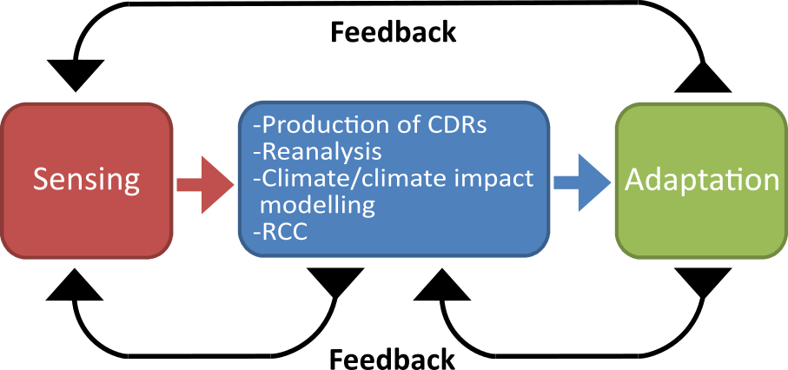
Figure 1 Workshop invitees will represent the information flow from adaptation community to data producers and to Space Agencies.

Background:
Addressing the challenges posed by climate change will require higher resolution data than that required to monitor and understand global climate change. For example: adapting to changes in precipitation requires detailed understanding of the rainfall patterns; and mitigating emissions of GHG through preserving forests needs high resolution satellite imagery. Furthermore, adaptation plans require inputs in the form of high-resolution spatially and temporally resolved data. Some of this information can be provided directly from satellite observations while in other cases reanalysis is used to fill gaps and provide a detailed spatial coverage. Climate reanalysis is an established tool for monitoring climate change, and is used both for research and education, to support the delivery of climate services and in support of commercial applications. They are also used in the development of global climate indicators, which describe the changing climate in a way that can be understood by non-experts.

Potential questions to be addressed during the workshop:
- How well do current CDRs (e.g. as listed in the ECV inventory) and other satellite-derived products support adaptation?
- How can the user needs for higher resolution information be fulfilled?
- How well are the user needs for uncertainty information being met?
- What are the anthropogenic influences captured in reanalysis? (change of land use both on an interannual and on a short-time scale basis, e.g. deforestation, irrigation)
- How do users communicate their needs to CEOS (Committee of Earth Observation Satellites), CGMS (The Coordination Group for Meteorological Satellites), RCCs and reanalysis centres?

Deliverables:
- Assessment of the current value chain from sensing to data production for climate adaptation applications (Fig 1).
- Design for a process to ensure systematic communication on ECV observations requirements between the adaptation community, RCCs, the reanalysis community, other CDR providers and satellite operators .

Format:
- 4-5 February: Meeting of the GCOS Task Team for Climate Adaptation Observations (attendance limited to invitees only).
- 6-7 February: 2-day workshop on space-based ECV observations for climate adaptation, including plenary discussion and breakout groups.

Proposed Agenda
6th February
Morning: 9:00-13:00
Plenary: How well do current CDRs and other satellite derived products support adaptation?
- Opening: GCOS, WMO
- Climate adaptation needs:
  - Task Team for Observations for Climate Adaptation
  - Adaptation and mitigation with focus on land use change
- Supporting Adaptation (all to include: how well are the user needs for uncertainty information being met? What are the anthropogenic influences captured in reanalysis, e.g. change of land us both annually and on a shorter time scale, e.g. deforestation, irrigation?)
  - Reanalysis: reanalysis products availability, observations (space and in-situ) needed to fill the gaps, including those for regional analysis.
  - RCCs: Their role and how they support climate adaptation. The products and services they provide
  - Climate and impact modelling community: how do they support adaptation

Afternoon 14:30–17:30
Breakout groups - 3 groups
Questions:
- How well are the user needs supported by the existing CDRs and other satellite-based datasets and how could this be improved?
- What are the user needs for uncertainty information and how can data providers better meet these needs?
- Are the anthropogenic influences captured by reanalysis, climate models and other data processing sufficient for the user needs or are there any other specific aspects that should be addressed by reanalysis and how can this be achieved?
Plenary: Presenting output from the breakout groups

7th February:
Morning: 9:00-12:30
Plenary: communication
  - WGClimate: How do space agencies respond to GCOS requirements for climate observations, what is available and how do they address gaps (e.g. surface-based observations for validation/calibration, improved models and data assimilation techniques?)
  - C3S: how do they ensure that they are responding to user needs?
  - GFCS: understanding data needs for adaptation
Breakout groups:
  - How should users communicate their needs to CEOS, GCMS, RCCs and reanalysis centres?
Plenary: presenting final output from the breakout groups
Lunch: GCOS team to prepare summary and output from the meeting
Afternoon 14:00–15:30
Plenary:
- Presentation: Strategic outlook
- Agree outcome of meeting, which should include a possible workplan to design a process to ensure that the user needs are communicated to the reanalysis community and to the data providers in a systematic way.

15:30: end of meeting

Draft List of Invitees:
- Reanalysis
  - ECMWF (ERA5-Hans Hersbach)
  - JMA (Shinya Kobayashi)
  - China (CMA-40 Jiang Lipeng)
  - US (NASA- Steven Pawson)
- Experts for satellite-based climate data records
  - WGClimate (Jörg Schulz)
  - AOPC Chair (Ken Holmlund)
  - SCOPE-CM (Jeff Privette)
  - ESA CCI (Pascal Lecomte)
- Climate Services: Adaptation and mitigation practitioners and scientists
  - TOPC Task Team on Adaptation (Nigel Tapper, Matthew McCabe, Paul Watkiss, Kelly Leilani Main, Ben Preston, Jean Palutikov, Gian Ziervogel, Hartwig Kremer)
  - C3S (Jean-Noel Thepaut, Dick Dee)
  - GOFC-GOLD (Martin Herold)
  - European Commission (Mark Dowell)
  - GFCS

- RCC representatives:
- Climate Data Experts:
- Phil Jones (AOPC member, climate expert)
- Karin von Schuckmann (Mercator Ocean, ocean reanalysis and services)
- WCRP WDAC:
- Experts from modelling community:
- WMO Secretariat
GFCS (Felipe Lucio)
WCRP (Michel Rixen, Matthias Tuma)
CCl (Omar Baddour)
Hydrology (Domenique Berod)

